*R*

*Y*

*B*

*Q5*

*Q6*

*Q7*

*Q8*

*Vdc2*

*R5*

*R6*

*R7*

*R8*

*Vdc2*

*Q1*

*Q2*

*Q3*

*Q4*

*Vdc1*

*R1*

*R2*

*R4*

*Vdc1*

*P1*

*P2*

*P3*

*P4*

*P5*

*P6*

*P7*



*P8*

*R3*

*Vdc1*

*Vdc2*

*Q9*

*Q10*

*Q11*

*Q12*

*Vdc3*

*R9*

*R10*

*R12*

*Vdc3*

*P9*

*P10*

*P11*

*P12*

*R11*

*Vdc3*

*N*

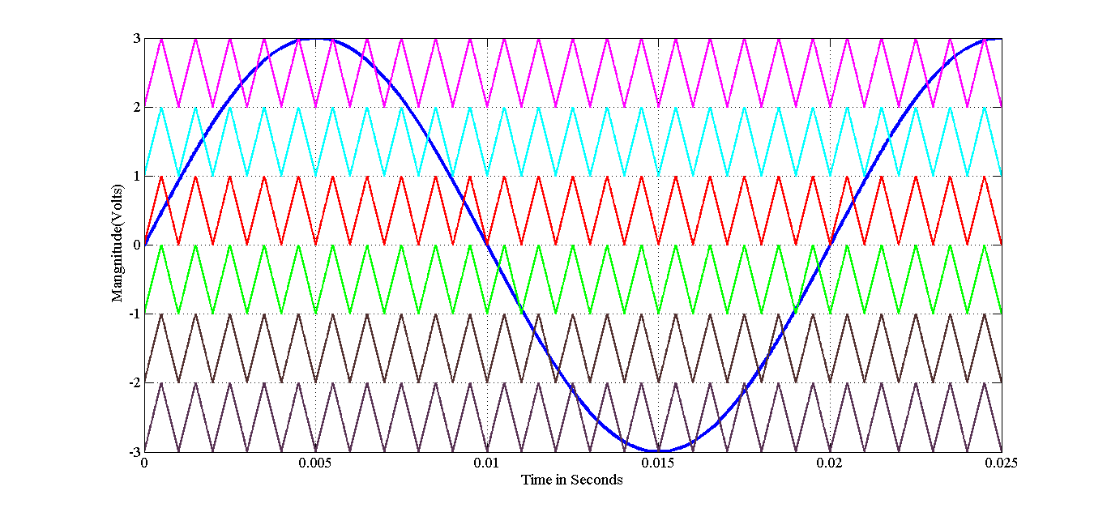

PDSPWM_7LEVEL

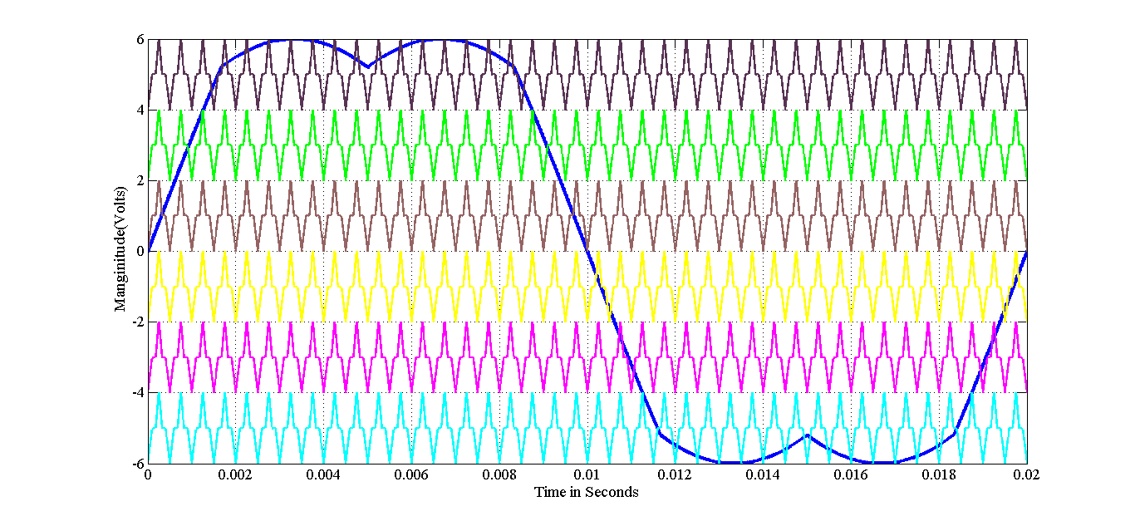

TTMC_PDSVPWM_7LEVEL

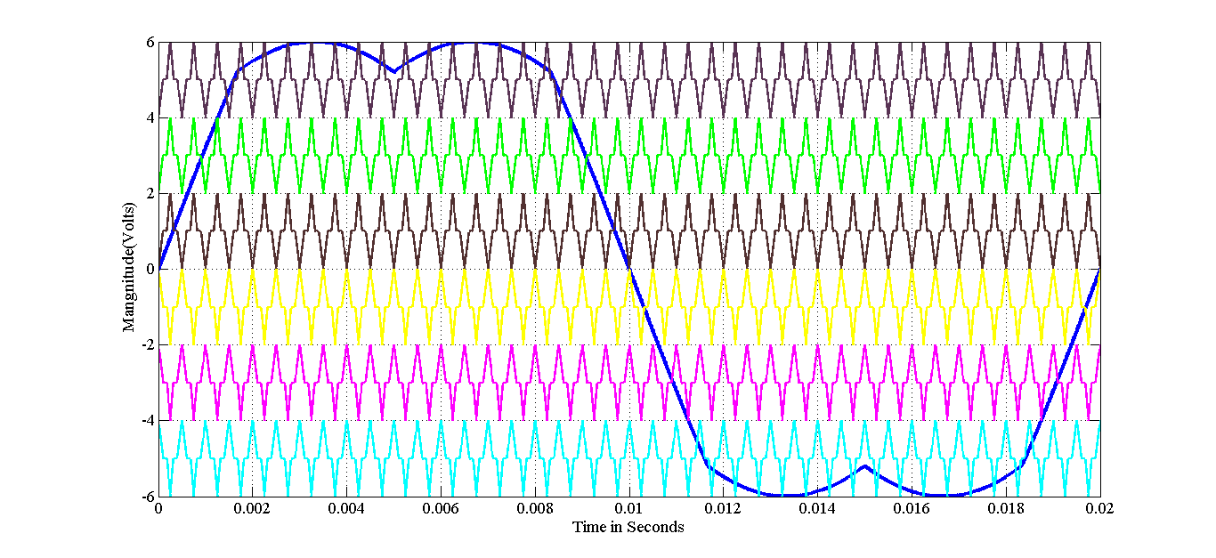

TTMC_PODSVPWM_7LEVEL

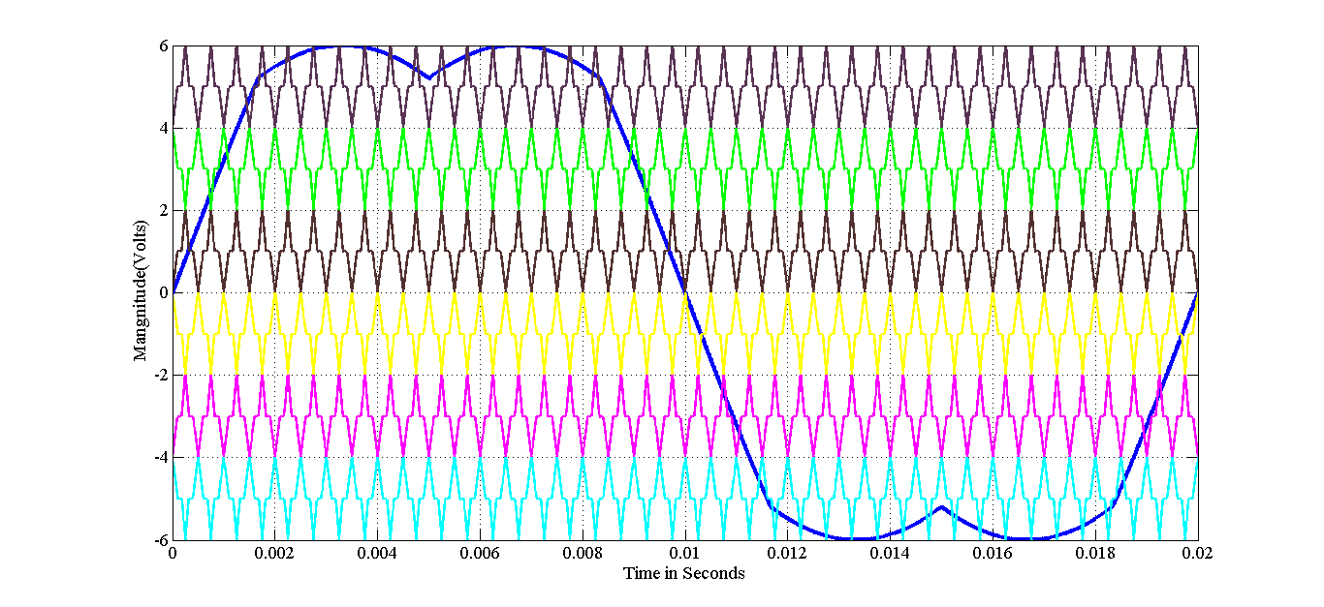

TTMC_APODSVPWM_7LEVEL

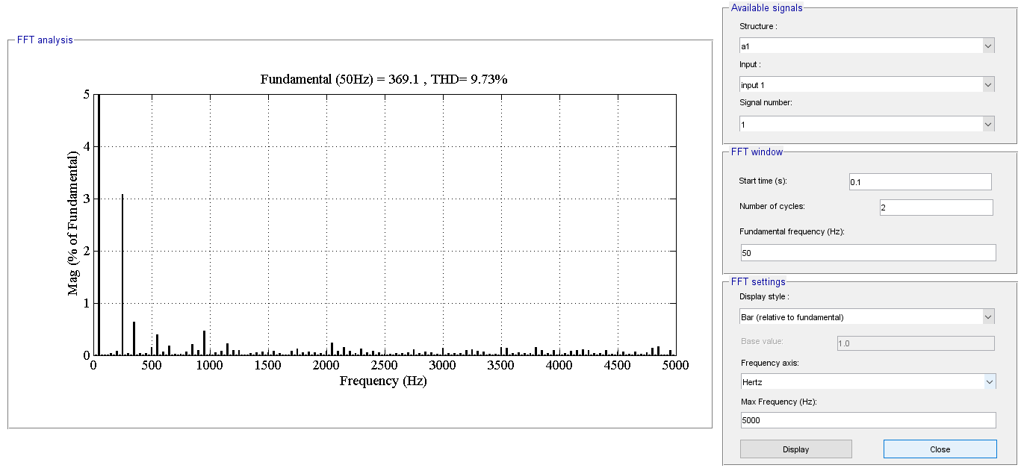

NPC_PD_SPWM

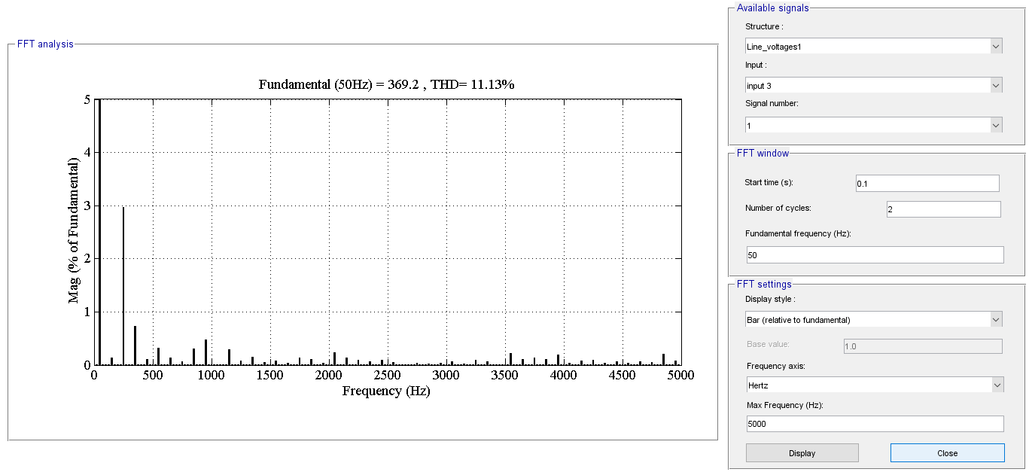

NPC_POD_SPWM

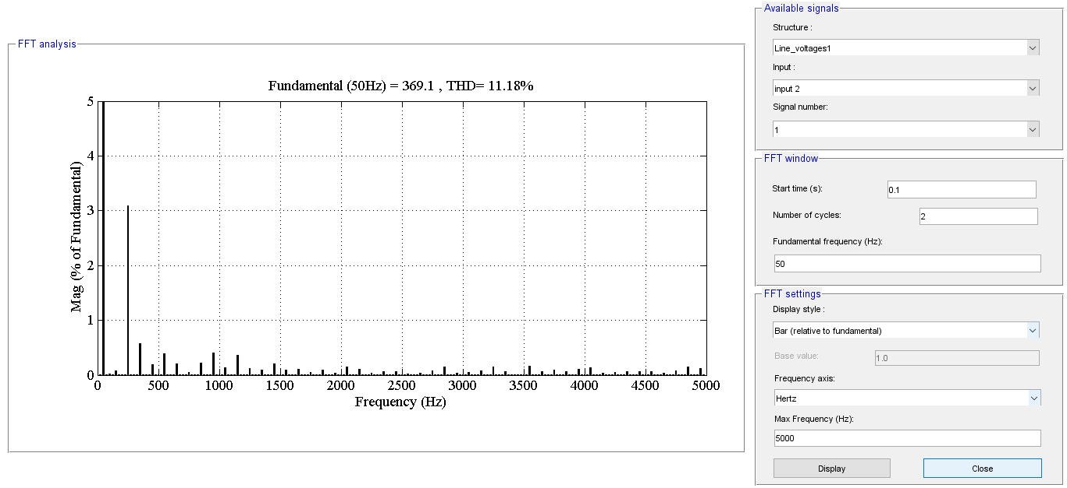

NPC_APOD_SPWM

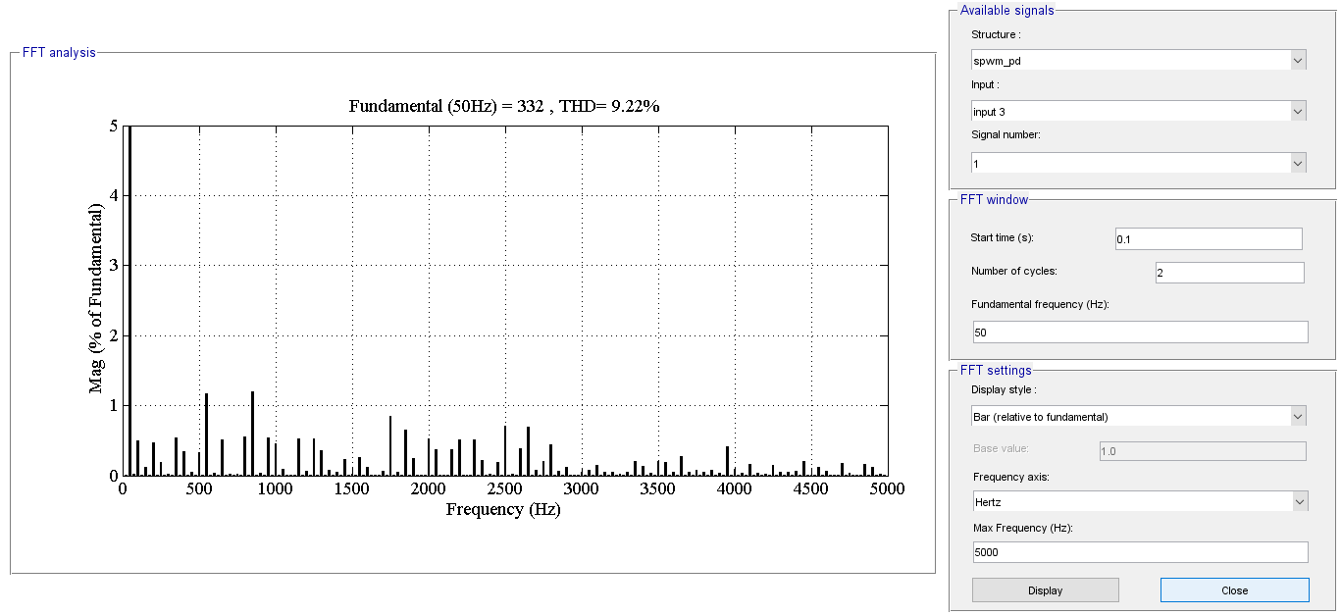

NPC_TTMC_PDSPWM

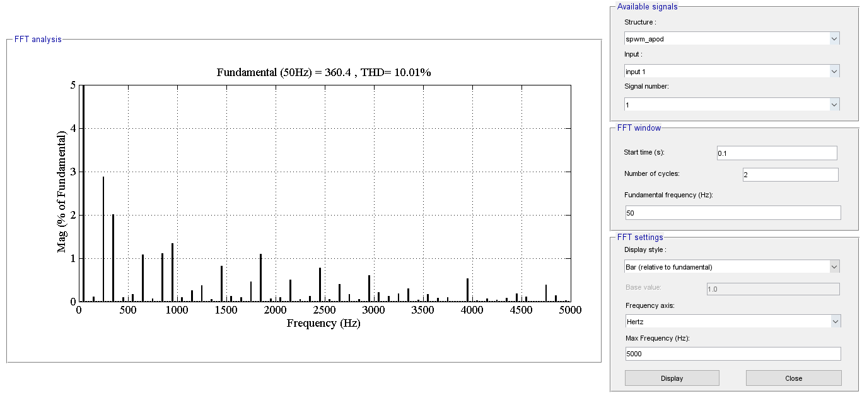

NPC_TTMC_APODSPWM

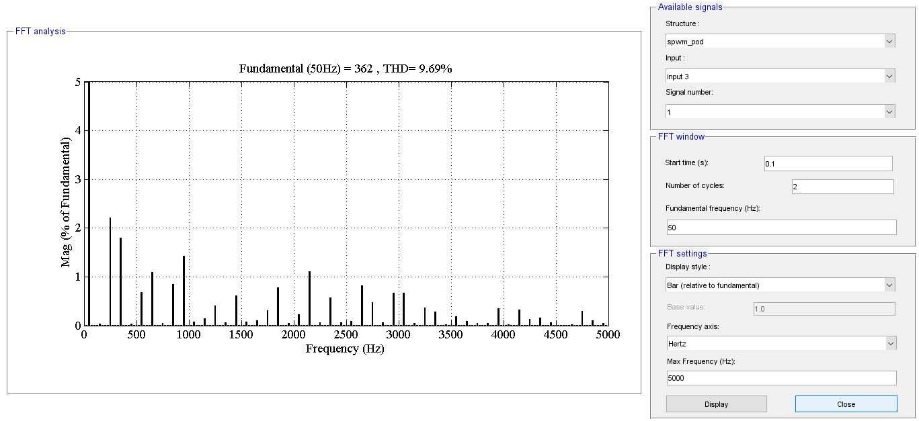

NPC_TTMC_PODSPWM

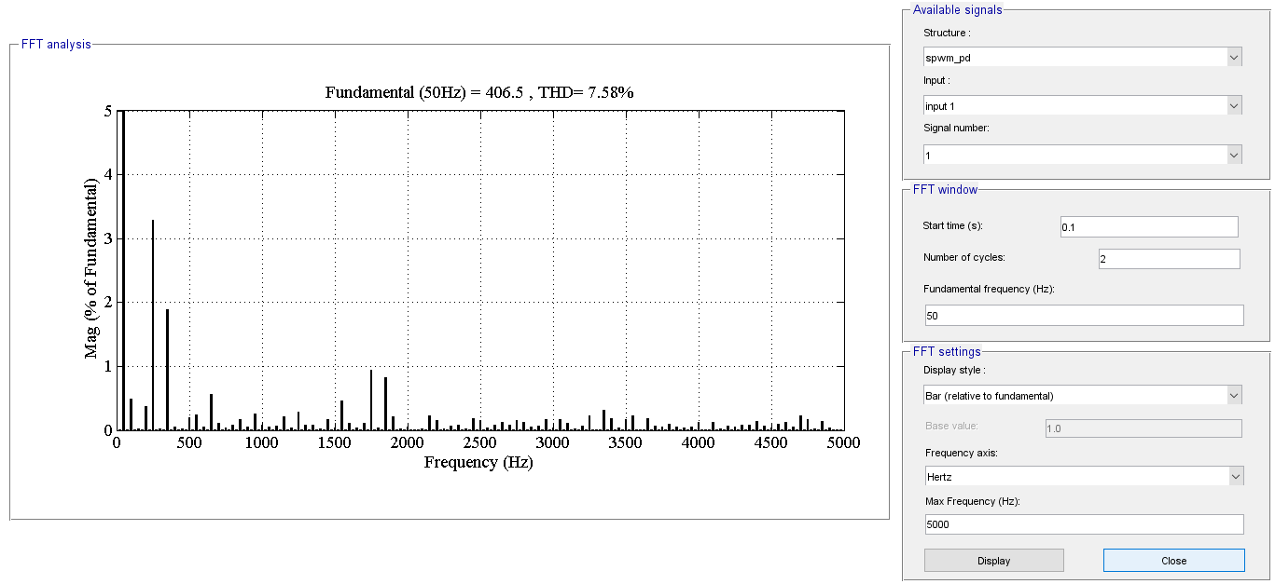

NPC_TTMC_PDSVPWM

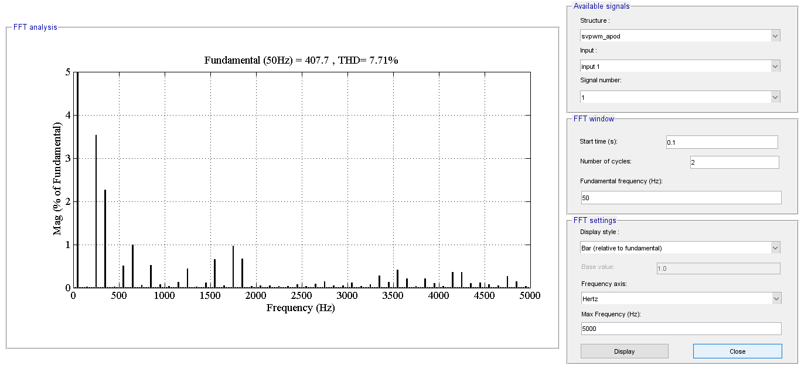

NPC_TTMC_APODSVPWM

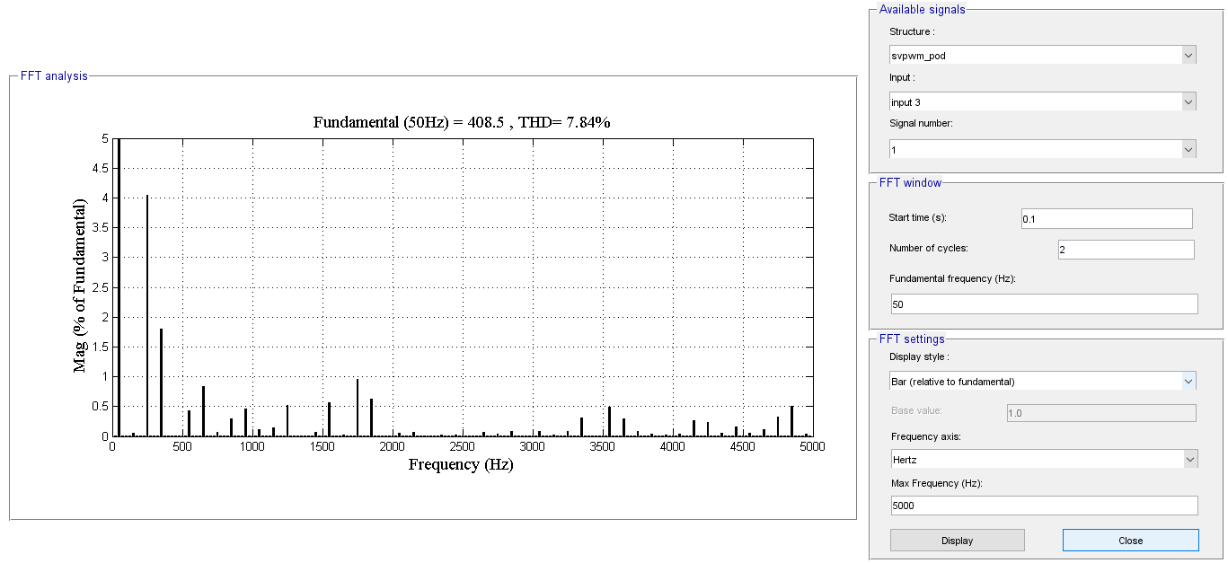

NPC_TTMC_PODSVPWM

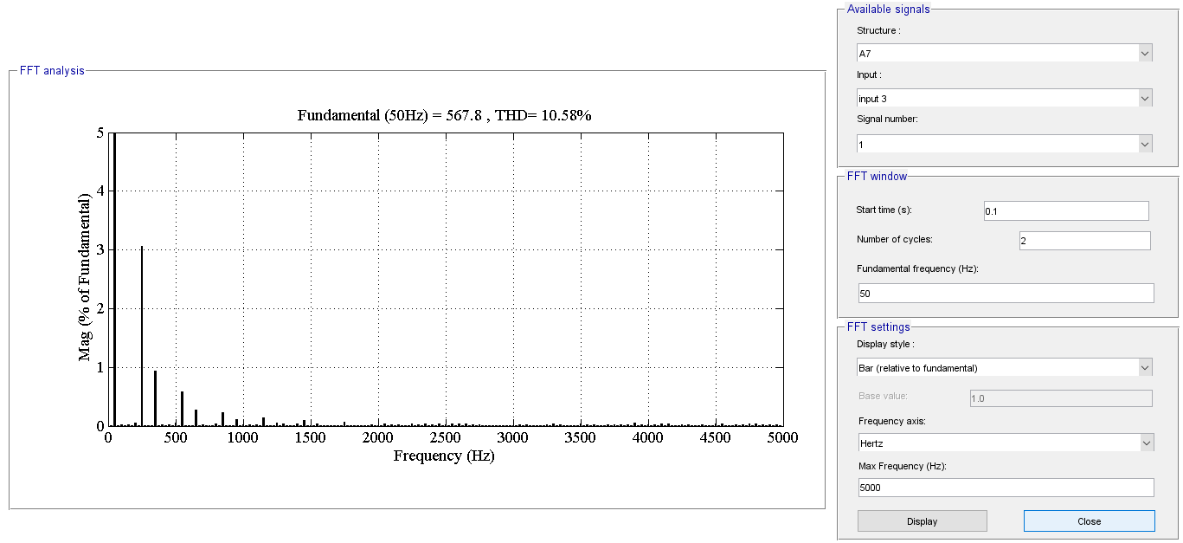

PD_SPWM

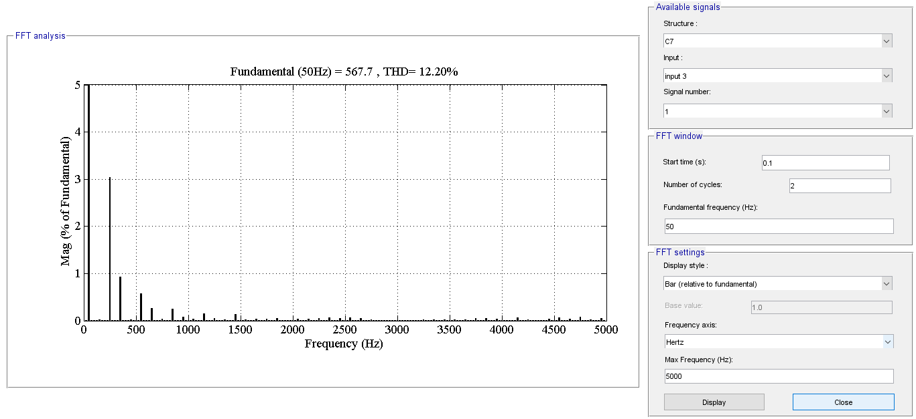

POD_SPWM

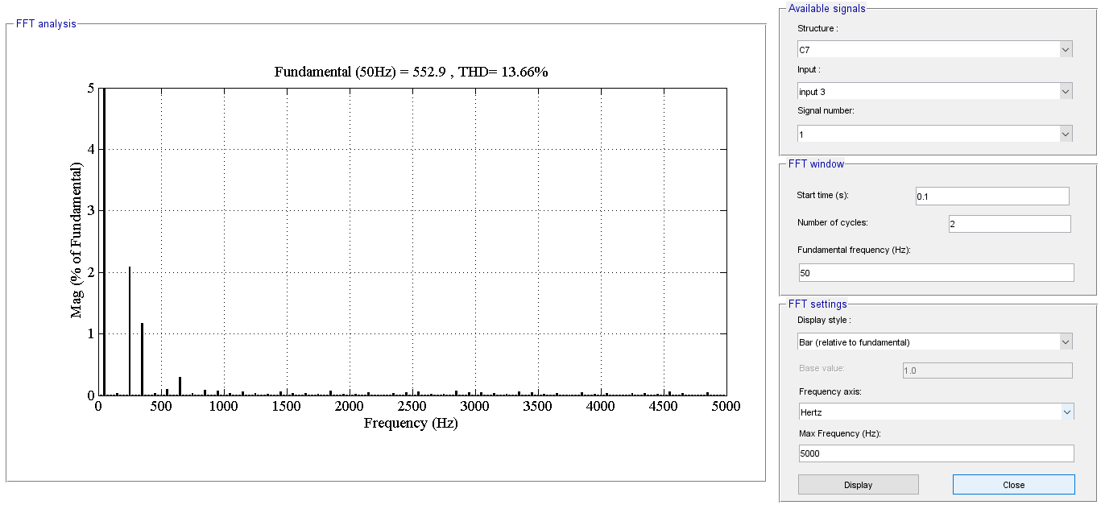

APOD_SPWM

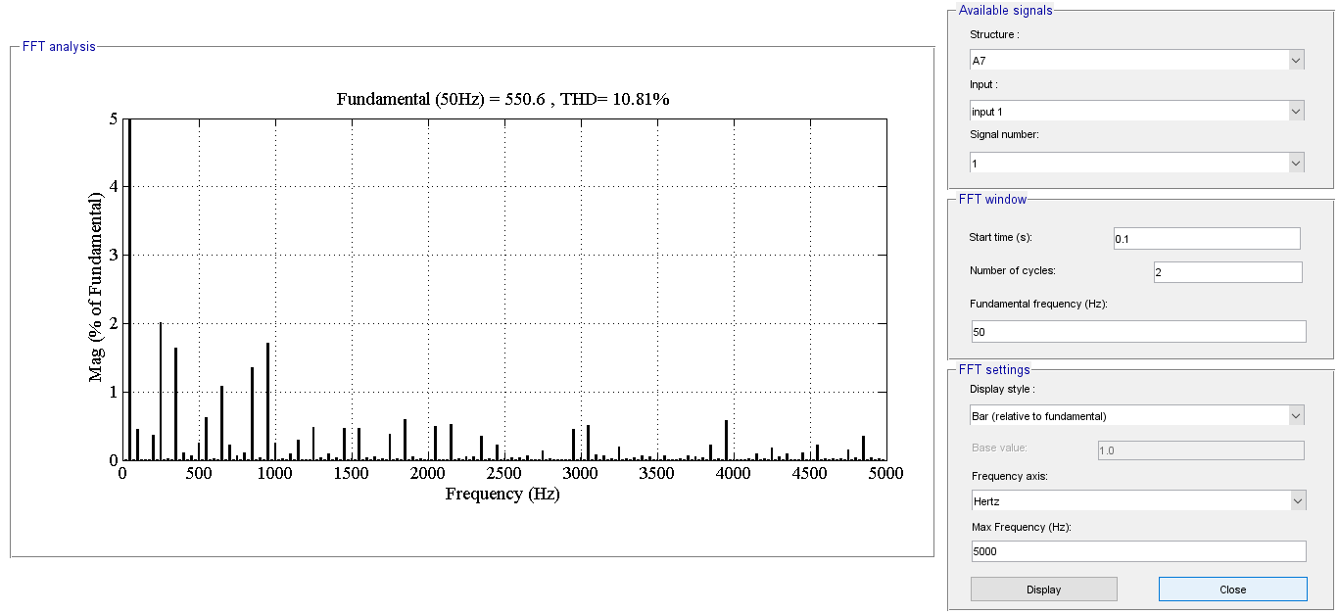

CHB_TTMC_PDSPWM

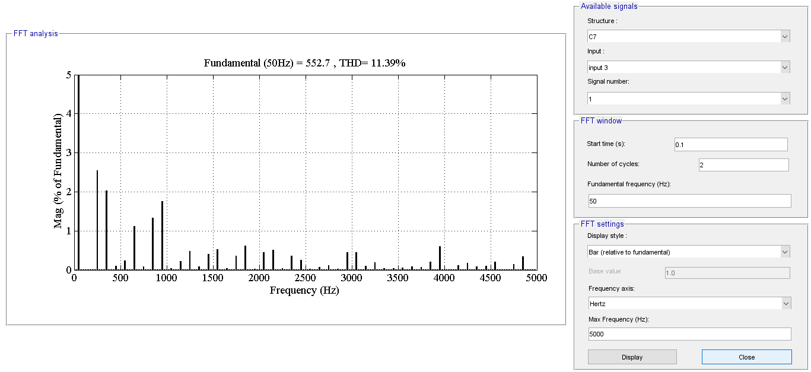

CHB_TTMC_APODSPWM

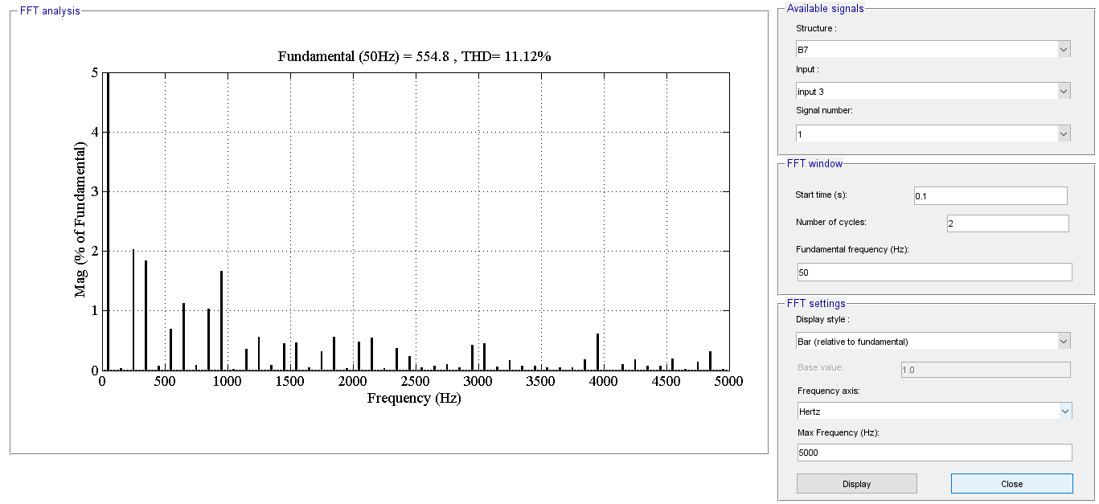

CHB_TTMC_PODSPWM

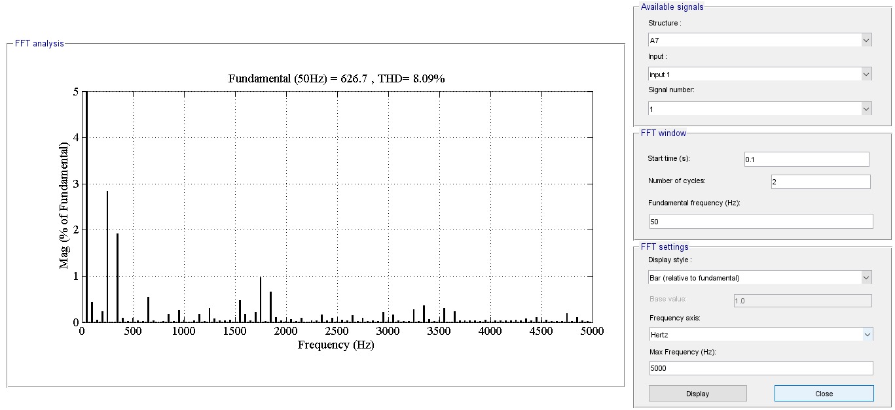

CHB_TTMC_PDSVPWM

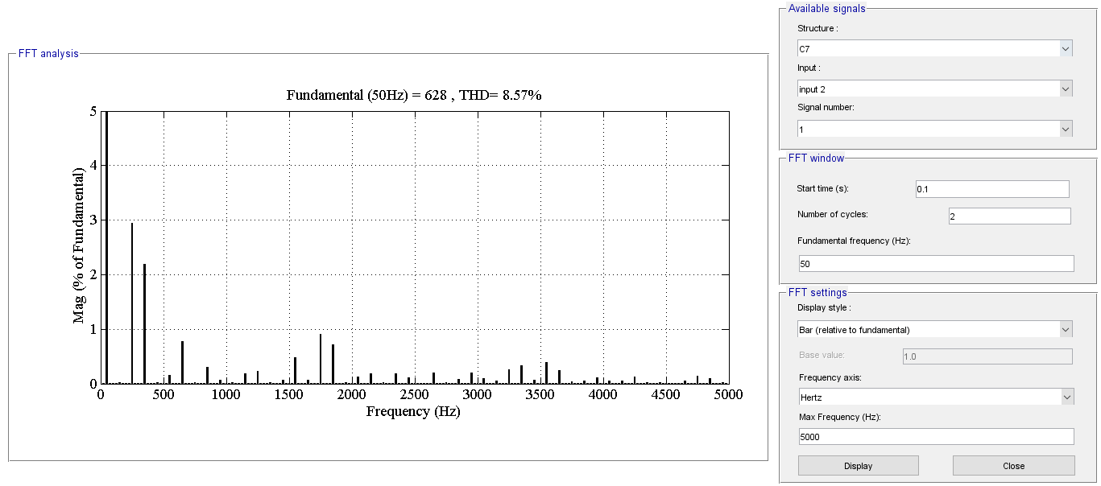

CHB_TTMC_APODSVPWM

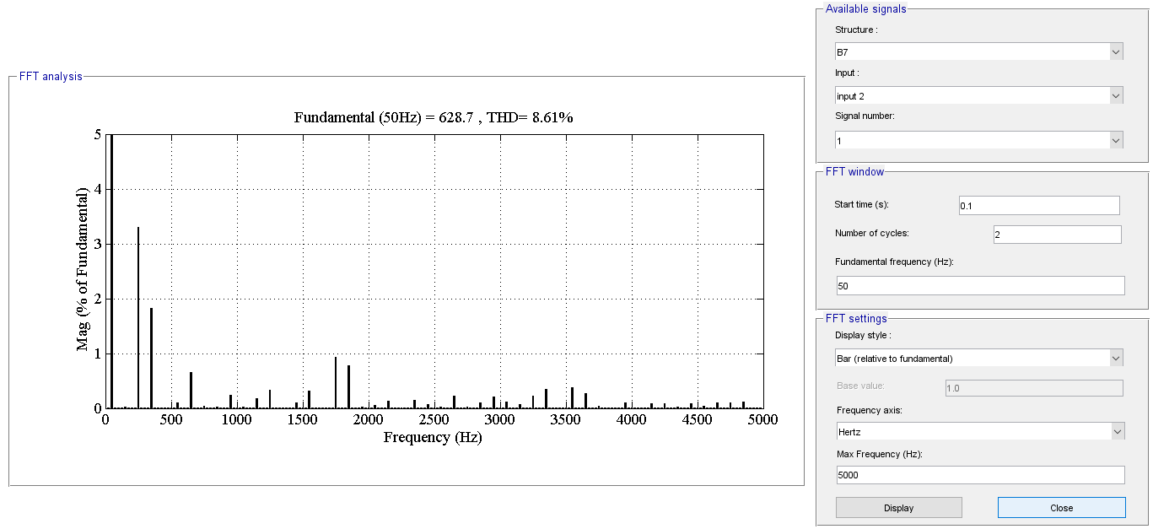

CHB_TTMC_PODSVPWM