Hybrid Deep Neural Network for Facial Expressions Recognition

Wijdan R. Abduhussein^{1*}, Nidhal K. El Abbadi², Abdul M. Gaber ³

¹Department of Computer Science, University of Technology, Baghdad, Iraq.
²Department of Computer Science, Faculty of Education, University of Kufa, Najaf, Iraq.
³Turath University College, Baghdad, Iraq.
¹wijdan_rashid@utq.edu.iq, ²Nidhal.elabbadi@uokufa.edu.iq, ³Abdulmohsen.jaber@turath.edu.iq
*Corresponding author: wijdan_rashid@utq.edu.iq

Article Info

Article history:

Received
Revised
Accepted

Keywords:
Facial Expression Recognition;
Transfer learning TL;
Convolutional neural network CNN;
Deep CNN

Abstract: Facial expressions are crucial indicators of human emotions. For years, facial expression recognition FER has caught the interest of many academics, yet it is still a hard task. Due to differences in head posture, occlusions, and illumination, recognizing expressions under natural situations remains challenging. Deep Neural Networks, particularly the Convolutional Neural Network currently commonly employed in FER. Several studies focus on recognize emotions from frontal images only, in this work images from the FER-2013 dataset have been exploits to make a more generalization model and solve some of the challenging tasks. It is an unbalanced dataset used in an ICML competition and various researches. It is among the most difficult datasets that only got 65.5 percent human level accuracy and it is freely reachable from Kaggle. This paper proposed a model for recognizing facial expressions using pre-trained deep convolutional neural networks and the technique of transfer learning. We developed a hybrid model using a combination of two pre-trained deep convolutional neural network, training the model in multiple cases to obtain more efficiency to categorize the facial expressions into seven classes. The adopted combination used EfficientNetB0 and MobileNetV2 architectures as feature extractors for the model with fine-tuning of parameters. The results show that, for the fer2013 dataset, the accuracy of our best model was 74.314 %. Thus, our proposed model outperforms other state-of-art classification methods without using any additional data, it is even outperformed the method that considered as the second highest accuracy for classifying the FER-2013 dataset. Therefore, our model ranked the second position among all methods that used extra data in addition to fer2013 dataset. Also exceeding all methods that not used any extra data.

Copyright © 2021 Institute of Advanced Engineering and Science All rights reserved.

Corresponding Author:
Wijdan R. Abduhussein ,
Department of Computer Science,
University of Technology,
Baghdad, Iraq.
Email: wijdan_rashid@utq.edu.iq

- INTRODUCTION
One of the strongest, natural, and global signals that reflect human emotions and state is facial expression. In the age of artificial intelligence, facial expression recognition (FER) is essential. Machines can give customized services based on human reaction data. Many systems, such as personalized suggestions, virtual reality, customer satisfaction, etc., rely on the ability to identify facial expressions quickly and accurately.
In recent years, due to the rapid growth happened in artificial intelligence, automatic facial expression recognition (FER) has an increasing interest among researchers in the field of computer vision, psychology, and pattern recognition [1], also, facial expression's classification has become a fundamental portion of computer systems and the quick interaction between humans and computers. It is used in many applications, including customer service, forensic crime detection, observation of victims in court, mentoring of students in academics [2], robotics, digital entertainment, advanced driver assistance, and monitoring systems [3], virtual reality, augmented reality, and education. Although many researchers work on developing the robust FER, still many problems and challenges reduce the recognition accuracy rate, such as illumination, noise, and occlusion that affect the feature extraction. In addition, the large data dimension can deteriorate the accuracy rate and recognition performance. Deep learning solved some of the problems but still needs a large amount of data to overcome the overfitting. In addition, many other parameters have a significant effect on the recognition performance, some of them are a variation of personal attributes that can cause high inter-subject variations, in addition to age, gender, ethnic backgrounds, and pose variation [4].
In this paper, while most work done involves adding extra training data from other sources and datasets to improve the accuracy rather than work on the recognition model itself, we will be focusing on only improving the recognition model without adding any data, and thus compare the current work with works of other researches. The rest of this paper organized as follows: section 2 focuses on the facial expression analysis, followed by related works in section 3. While section 4 introduced a general background, about three of the main methods used in this work CNN, Deep CNN, and transfer learning. Then we covered the proposed model in section 5. Results and performance comparing have discussed in sections six and seven. Finally discussion and conclusion section.

- FACIAL EXPRESSION ANALYSIS
In human communication and behavior, facial expressions are extremely important. Paul Ekman was the first American psychologist to distinguish six basic categories of facial expressions: anger, disgust, fear, happiness, sadness, and surprise remain the same among various cultures. He then launched the Face Action Encoding System (FACS), in which he explains more than 40 different facial action units (AUs) [4].
With the advancement of artificial intelligence technologies, deep learning's remarkable progress, and the growing demand for applications that use big data, FER research will increasingly concentrate on spontaneous expressions in the wild. In such complicated situations, new solutions for problems such as multi-view, occlusion, and multi-objective are required. In general, a FER system consists of several phases, as indicated in Fig. 1.

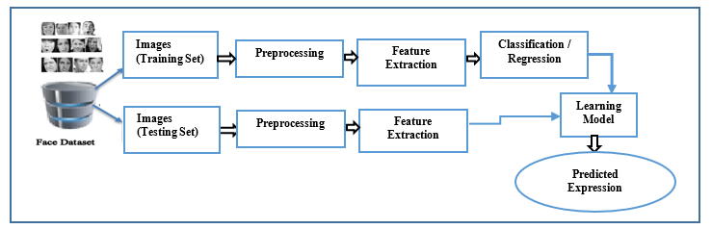
Figure 1. Conventional diagram for FER system.

- RELATED WORKS
Many strategies have investigated for FER, they have grouped into two main classifications: classical and deep learning-based methods. Several studies examined the different FER techniques. This section provides a summary of the most modern approaches.
Zhao and Zhang [5] merged the neural network with a deep belief network (DBN) for FER. In [6] they employed a conventional CNN and two of the convolutional-pooling layers on self-collected images for face emotional.
Mollahosseini et.al. [7] investigated a more complicated architecture with four layers from type inception and two layers from convolutional-pooling. According to [8], multiple CNN learned using different filter's size, with fully connected layers different numbers of neurons have been tested. Although in [9] the trained of hundred CNNs have been done , they only employed a limited number in their final model and it is taken as an ensemble of CNNs. Jain et al. described the development of a CNN-RNN hybrid deep learning system in [10]. Also in [11], a hybrid system has developed with TL, where SVM used to classify features obtained from AlexNet. The researchers of [12] used CNN for DWT obtained features.
Liliana [13] employed architecture containing eighteen convolutional and four subsampling layers to get her results. A CNN-based clustering technique for FER has proposed in [14]. Authors in [15] used a graph based on CNN to investigate FER from facial landmark characteristics. Experimented with various data augmentation approaches, such as using synthetic images, and discovered that a combination of synthetic data, as well as other methods, performed well for facial expression recognition [16].

- GENERAL BACKGROUND ABOUT TRANSFER LEARNING (TL), CNN, DEEP CNN MODELS
The FER has tested using a variety of pre-trained deep convolutional neural network models to see which one was most suited for it. This section explains CNN, as well as various DCNN models and TL.

- CONVOLUTIONAL NEURAL NETWORK (CNN)
CNN's are a class of deep learning networks that are used for processing by a grid pattern and they are most typically used to evaluate visual imagery [17] [18]. It has built to mechanically and proactively discovers spatial hierarchies of characteristics from level patterns, from low-level to high. Employing convolutional layers instead of fully connected has essentially two key benefits, the first one is sharing of parameters, and the second one is the sparsity of connections, thus reduces the number of parameters and speeds up the computation [19]. Three types of blocks (or layers) make up CNN, "convolution, pooling, and fully connected layers". The convolution and pooling layers extract features, while the full layer transfers those features to the final output. A CNN's filters slide across an image-using convolution to discover interesting patterns, and usually, its activation function is ReLU, which provides a feature map that adds to the next layer. Other layers such as "pooling, fully connected, and normalization" layers may be added after this [18].
A convolution layer is an important part of CNN, which made up of stacking of arithmetic computations, as convolution ًwhich is a particular form of a linear operation. Pooling is a non-linear downsampling technique where pooling layer merges non-overlapping areas from one layer to generate a single value that is transfer to the next layer. Feature maps can evolve hierarchically and progressively and be more complicated as the output from one-layer feeds to the next. Training is the process of adjusting parameters like kernels (filters) to reduce the difference between outputs and ground truth labels using optimization methods such as gradient descent, backpropagation [19]. Forward propagation refers to the process of transforming input data into output data across layers. Fig. 2 depicts the typical architecture of a conventional CNN and training.

- TRANSFER LEARNING AND DEEP NEURAL NETWORK
At the ImageNet Large Scale Visual Recognition Challenge (ILSVRC), After CNN surpassed the models; they garnered a lot of attention. The ILSVRC is an object classifying and detecting competition with millions of images and hundreds of categories. From 2010 until now, the competition has been held annually, with over fifty colleges participating [22].
From 2012 to 2015, the famous CNN models that achieved the best accuracy and won in the ILSVRC were: AlexNet , where CNN employs a five-layer system [23], then ZFNet is built on the same concept, except the difference it has fewer parameters, where the large kernels swapped out for smaller ones [24], GoogLeNet, VGG-16 [25] presented a broader model containing thirteen convolutional layers with smaller kernels.

Using sixteen convolutional layers, VGG-19 is another model from this type [26], and ResNet [27], in which the skip-connection was first proposed and it has become a key concept used by models that come following later. Currently, a few distinct ResNet models with varying depths are published, including ResNet-18, ResNet-34, ResNet-50, and ResNet -52. Later DenseNet [28] featured dense skip connections among layers in addition to a single skip link. Meaning is that every layer gets signals from the above layer, and other succeeding layers use each layer's output. The input of a layer is coupled with the channel aggregation from the previous layers. There are numerous variants of this paradigm.

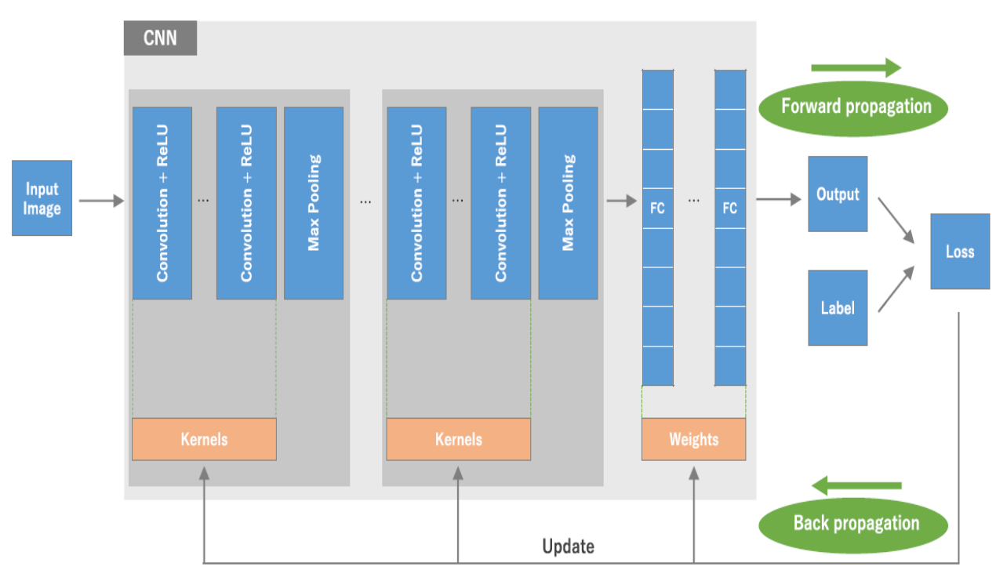

Figure 2. The architecture of a standard CNN and the training process ^{[18]}.

DCNN features numerous hidden convolutional layers, and it works with images of large size, this makes inputs and training extremely difficult. Every DCNN models has distinct important layouts and interconnections [20]. Due to many parameters, training large DCNN model is a difficult undertaking. A huge network frequently necessitates a significant amount of training data. Due to the high cost of data collecting and costly annotation in some disciplines, such as bioinformatics and robotics, building a large-scale well-annotated dataset is extremely challenging, limiting its evolution. However, transfer learning [29], which is focused on knowledge transfer between domains, is a potential machine learning strategy for overcoming the above difficulty, and the researches have demonstrated that TL[30][31] can even be highly effective in solving such issue. Deep learning has recently gotten a lot of interest from researchers as a modern categorization platform, and it has been effectively implemented in many different fields.
Transfer learning TF is a useful approach for dealing with the limited training examples. Instead of learning from the beginning, the model might begin utilizing the pre-trained weights [20]. It attempts to transfer the knowledge from the source to the target domain by loosening the requirement that the training set is independently and identically distributed as the test data [32]. This will have a significant positive impact on a variety of areas that are hard to enhance due to a lack of training examples. Fig. 3 depicts a conceptual diagram of the TR approach.
TL is a strategy that enables employing representations of knowledge obtained through a variety of tasks that have similar applicability. It has been observed that the TL performs better if the two tasks were identical [30]. More recently, it has been explored on tasks that are not related to its training, also it has shown to be effective [33].
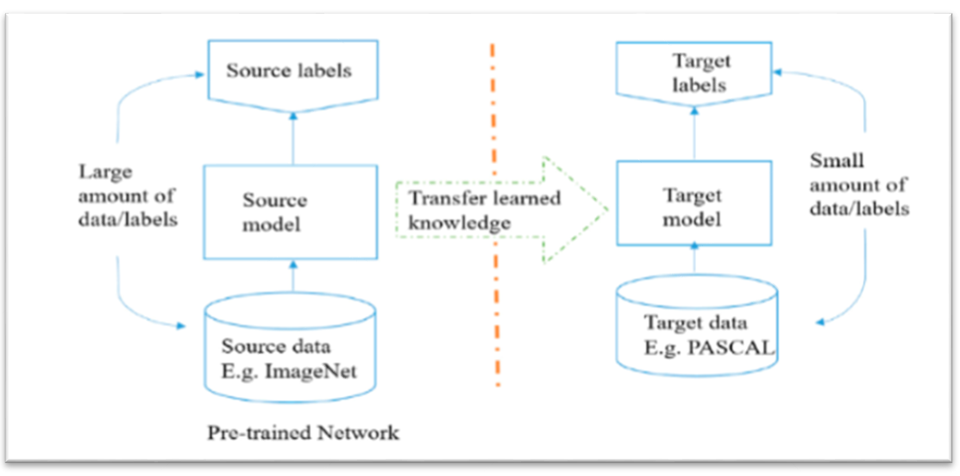
Figure 3. Conceptual diagram of TR: Pre-trained using ImageNet and retraining using PASCAL dataset ^{[20].}

- THE PROPOSED MODEL
In this section, the proposed model for FER has described. This model includes two parts: the features extraction part and the classifier part. The features extraction part result from integrating the features we get from pre-trained models MobileNetV2 and EfficientNetB0 that have trained on the ImageNet dataset. The training of the models will be in two cases as described later. The best one taken as the final best model.

- THE FER2013 DATASET
The dataset that has been used is the FER2013 dataset, which consisting of 35887 grayscale images with sizes (48x48), all images are the cropped faces, and samples of these images are shown in Fig. 4. FER2013 dataset has the basic seven expressions, are "angry, disgust, fear, joy, neutral, sad, surprise". The challenges of these images are a small size and the low resolution for the image, in addition to highly imbalanced, because the number of images is different from one emotion to others, making it hard to obtain a model that can work well and accurately for all expressions.
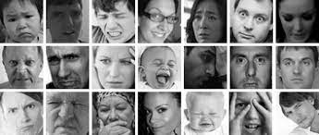

Figure 4. Samples of images for different emotions from FER2013 Dataset

- PREPROCESSING THE DATASET
Preprocessing can be summarized as methods for resizing the image to the proper size as the model requires, converting images to RGB, reshape image array to desired dimensions. Then the images' arrays and the corresponding label will be saved as (.pkl) file ; " This is a file generated by Pickle, a Python module that allows items to be serialized as files on disk and then deserialized back into the application as needed. It reloaded into memory during execution time to save space in storage or transition. Then the file can be used directly for reading data instead of reading the images every training, thus will reduce the requires time taken for training and testing, also data augmentation has been used to increase sample size, reduce overfitting, and increase generalization. The data augmentations that been used are (Flip, Shift, Rotate, and Zoom). In this work, the distribution of data as training and testing data are unchanged of data images as stated in the original dataset page, with 28709 training samples and 3589 validation samples, without adding any external images as the other researchers did, where a lot of researchers used external images from other datasets or those that are self- obtained images.

- THE ARCHITECTURE OF THE MODEL
The proposed model structured as shown in Fig. 5(a) , the weights from the pre-trained models such as (EfficientNetB0 and MobileNetV2) transferred to the newly built model by taking only the features extraction part from it, left its old classifier, and replaced with new classifier. Features of EfficientNetB0 and MobileNetV2 models been combined to create a feature extractor part for the model.
The Classifier part is created by adding two Dense-Dropout layers with (4096 and 1024) neurons respectively. The activation function that been used in these layers was of type RELU. The last layer of the model is the Dense layer with seven neurons (because the model will be used to "classify image to one of seven expressions") and the activation function was Softmax.

TRAINING THE MODELS
In general, when the models have been trained using transfer learning, the training speed can be faster, then the weights of its feature extraction layers (ignore the classification part) can be used to initialize the feature extraction layers of a new model. In addition, to increase the accuracy and generalization of the model, fine-tuning techniques are used. The proposed model that described in previous subsection has been training for two cases:
- Case 1: freezing the features extraction part and training only the classification part, the extracted general features will be good enough at the start. Freezing the extraction part allows the classification layers to get some knowledge about what features to look for in the output, it takes less training time than other cases because the parameters that need training are less.
- Case 2: fine-tune the extraction part and the classification part, so the whole model trained without freezing any part. This will make the learning process give better accuracy, but it takes more training time.

- EXPERIMENTAL RESULTS
The parameters that used for training all models is listed in Table 1, the following subsections explain the results obtained from training two pre-trained models separately, and that get from the proposed combining models trained in two cases (directly using the weights from pre-trained models on ImageNet and by using our two pre-trained models weights trained on FER-2013 separately).
Table 1. Training parameters
Parameter | Value
Input Image Size | 200x200x3
Image Color Space | RGB 3 Layers
Batch Size | 32
No of Epochs | 100
Dropout Rate | 0.2
optimization function | ADAM
Learning Rate | 0.001

THE EFFICIENTNETB0 MODEL
In this model, the weights from the EfficientNetB0 model are transferred to the newly built model by replacing its old classifier with the new classifier consist of two Dense-Dropout layers with (4096 and 1024) neurons respectively and Rectified Linear Unit (RELU) activation function also, the last layer is the Dense layer with 7 neurons and Softmax activation function. The structure of this model shown in Fig. 5(b).
The model been trained by fine-tune both parts (features extractor and the classifier). Model accuracy and Loss for this case are plotted in Fig. 6 and the best accuracy was (0.7299) at epoch 91. The confusion matrix and the classification report on testing the final best model on test set of FER2013 shown in Fig. 7.

THE MOBILENETV2 MODEL
The MobileNetV2 has been trained using the same strategy for EfficientNetB0 in the previous subsection with same structure shown in figure 6 except that EfficientNetB0 replaced by MobileNetV2.The best accuracy for the training with fine-tuning was (0.70926) at epoch 99. Model accuracy and Loss have plotted in Fig 8. The confusion matrix and the classification report on testing the final best model on test set of FER2013 is shown in fig 9.

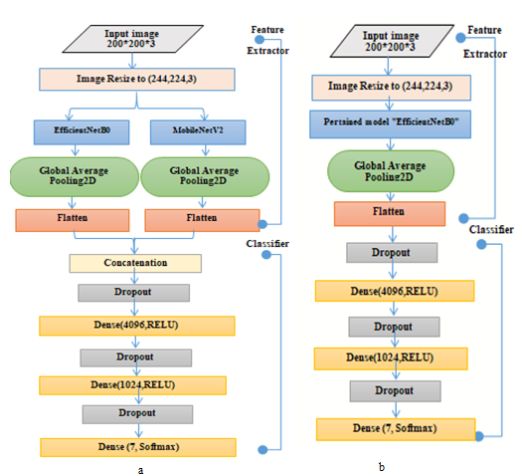
Figure 5. a) The structure of the proposed EfficientNetB0 model. b) The structure of the proposed hybrid model
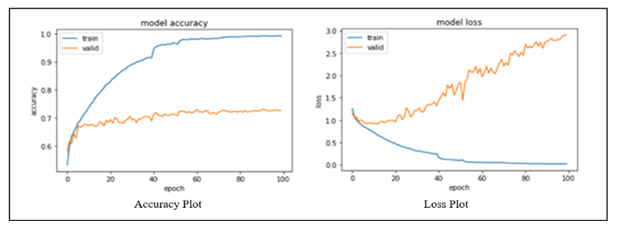
Figure 6. The proposed EfficientNetB0 Model: accuracy and loss after fine-tuning
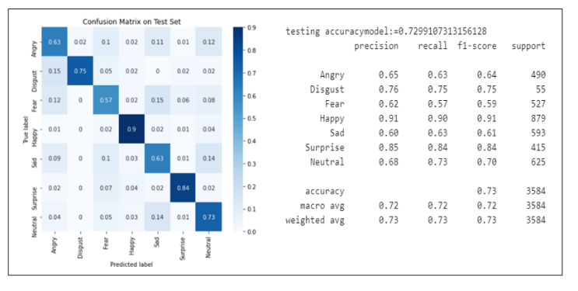
Figure 7. The confusion matrix and the classification report of the final best EfficientNetB0 model on FER2013.
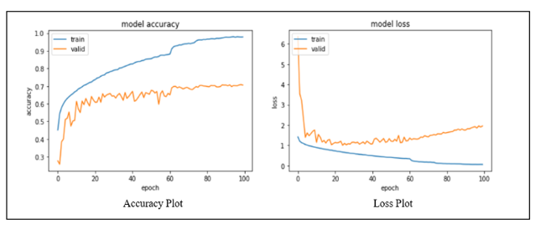
Figure 8. The proposed MobileNetV2 model: accuracy and loss after fine-tuning
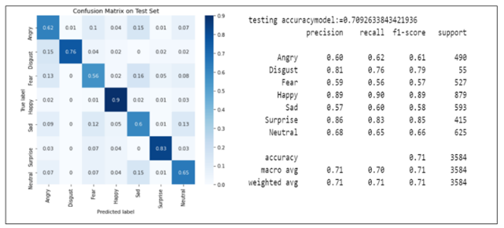
Figure 9. The confusion matrix and the classification report of testing the final best MobileNetV2 model on FER2013 test set

HYBRID MODEL USING FEATURES EXTRACTION PARTS PRE-TRAINED ON IMAGENET.
The proposed hybrid model that described in the previous section been trained in the two cases with the following results:

Case 1: training by freezing the features extraction parts of the model, the accuracy and loss have plotted in Fig. 10; the best accuracy was 0.588 at epoch 147.

Case 2: training by fine-tuning (unfreezing) the features extraction parts of the model, the accuracy and Loss have plotted in Fig. 11, in this case, the best accuracy was 0.7322 at epoch 74. A confusion matrix and a snapshot of the classification report contain "precision, recall, f1-score, support" metrics obtained from testing the hybrid model after case 2 are shown in Fig. 12.

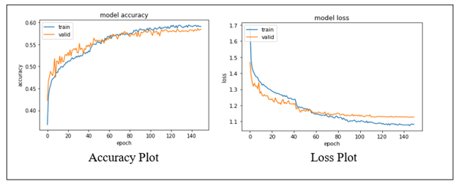
Figure 10.The proposed hybrid model using pre-trained features extraction parts pre-trained on ImageNet: accuracy and loss after case 1
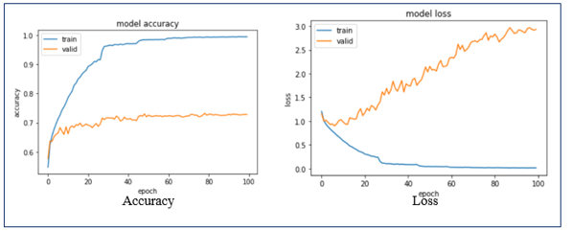
Figure 11.The proposed hybrid model using pre-trained features extraction parts pre-trained on ImageNet: accuracy and loss after case 2
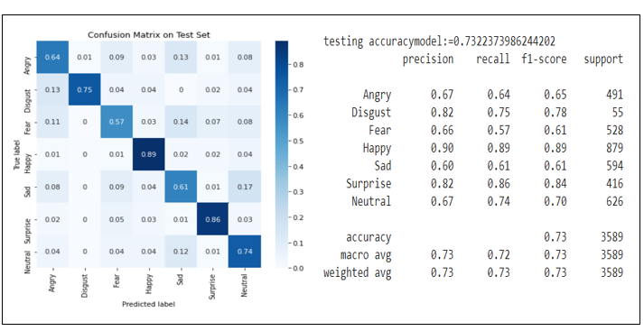
Figure 12. The confusion matrix and the classification report of testing the proposed hybrid model (pre-trained on ImageNet) on the FER2013 test set using after case 2

HYBRID MODEL USING FEATURES EXTRACTION PARTS PRE-TRAINED SEPARATELY ON FER2013 ITSELF.
The weights from EfficientNetB0 and MobileNetV2 models that trained as described in subsection A and B in this section used as the features extraction parts for our model. By only freezing the features extraction parts, the model got the higher accuracy (0.7430) at epoch number 34. The increasing accuracy results may be because of the good features (weights) obtained from the feature extraction parts. The accuracy and Loss for the final best model shown in Fig. 13. In addition, the confusion matrix and a snapshot of the classification report contain "precision, recall, f1-score, support" metrics obtained from testing the best hybrid model are shown in Fig. 14.

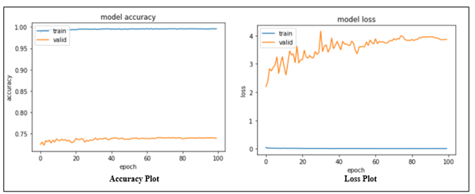
Figure 13. The proposed hybrid model using features extraction parts pre-trained separately on fer2013 itself: accuracy and loss
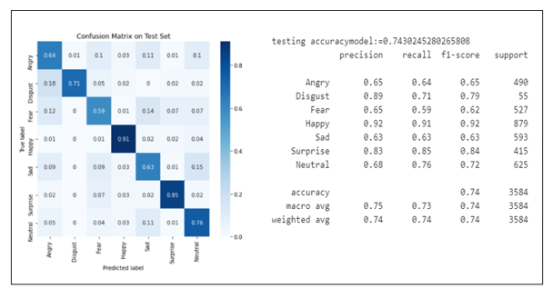
Figure 14. The confusion matrix and the classification report of testing the final best hybrid model (features extraction parts pre-trained separately) on the FER2013 test set.

- PERFORMANCE COMPARISON
Table 2 listed all the results of training the models that we done. Training the model from the base means that it is depending on the pre-trained weights from the ImageNet dataset, .Training it using loading weights means that its weights obtained from training each model (EfficientNetB0, MobileNetV2) separately on FER2013 dataset. FER2013's prior reported classification accuracies shown in Table 3 with a comparison with best of ours two models.
As clear that the best-reported accuracy that achieved without using of any additional data was 73.28 % .As detailed in [34]. We did not add any data for training the models and depending only on the dataset with its challenges, the best-achieved accuracy was 74.30 % by combining the two models (EfficientNetB0, MobileNetV2) that trained separately on FER2013.

Table 2. Comparison between our models.
The model | Results
The model | Accuracy % | Best Epoch
EfficientNetB0 | 72.99 | 91
MobileNetV2 | 70.926 | 99
Hybrid Model from base : FFª | 58.629 | 147
Hybrid Model from base: TT^{b} | 73.22 | 74
Hybrid Model with loading Weights FFª | 74.30 | 34
a: (MobileNetV2_classifier.trainable = False , EfficientNetB0. .trainable = False)
b:(MobileNetV2_classifier.trainable = True and EfficientNetB0.trainable = True)

DISCUSSION AND CONCLUSIONS
This research provides a method for recognizing facial emotions using pre-trained deep Neural Networks and the TL by developed a hybrid model using the combining of EfficientNetB0 and MobileNetV2 to categorize facial expression into seven categories.
It is noticed that fine-tuning the model gives efficient performance because each model can catch some of the facial muscle's movements and extracting features by its structure, filters, and layers. This is illustrated by the results, which show that the fine-tuned hybrid model (ImageNet's weights) achieved 73.22 accuracy, whereas the same model without any tuning to the feature extraction parts achieved 58.629 fewer accuracy even when training for a larger number of epochs.
Table 3. Comparison with recently models on FER2013 dataset
Year | Model / Method | Accuracy %
Proposed | Hybrid Model with loading Weights from our pre-trained fer2013. | 74.30
2020 | Residual Masking Network (using extra data) [35] | 74.14
2021 | VGGNET [34] | 73.28
Proposed | Hybrid Model with loading Weights from ImageNet. | 73.22
2016 | VGG [36] | 72.70
2016 | Resnet [36] | 72.40
2021 | CNN Hyperparameter Optimisation [37] | 72.16
2016 | Inception [36] | 71.60
2021 | ARM( ResNet-18) [38] | 71.38
2019 | AttentionalConvNet [39] | 70.02
2016 | Con+Inception layer [7] | 66.40
2019 | VGG+SVM [40] | 66.31

Due to the limitation of the resources like (RAM, GPU, CPU), the training was for just 100 epochs, except that without tuning there is trying to train for 150 epochs in order to get better accuracy, but as we see there is no any enhancement. For more epochs, this will slows the training and elapses more time because training the model on a large dataset required a lot of computational operations and memory.
As the results have shown, Our models outperforming other state-of-the-art classification methods without using any additional data and the best model gives accuracy equal to 74.30 %. This accuracy is highest than all the models that are not used extra data (the highest accuracy for methods that not used extra data was 73.28 [34]).
It even outperforms the method that is considered the second-highest accuracy for the classification of expressions [35] using the fer2013 dataset with 74.14 % accuracy according to the site (https://paperswithcode.com/sota/facial-expression-recognition-on-FER-2013). In addition, their model is more complex and requires high resources.
In this case, the best-proposed model in this paper ranked the second position among all methods in the classification of facial expressions for the FER-2013 database, exceeding all methods that not used extra data; also, it can be used in devices with limitations resources.
The accuracy of the happy and surprised expressions was the highest, but the fear, sadness, and angry expressions had less accurate. It has maybe natural because the first two expressions have more images than the rest and their features are distinctive. On the other side, even for the human, it is difficult for classifying some of such images. This may be because the features for these expressions more similar to each other, that is leads to confusion and inaccurate classification.
Table 4 displays the largest amount of confusion between expressions. The largest confusion was between Disgust expressions and angry expressions where the model predicted 0.18 % of Disgust expression as angry expression, sad expression confused with neutral expression with value 0.15, fear expression with sad expression by 0.14.
Furthermore, it is clear that only anger expression has been predicated as disgust expression, and in a very small percentage that is almost negligible about 0.01. Thus the model does not predict wrongly any other expressions as disgust.
Thus, the combined model becomes more accurate in categorizing and distinguishing different expressions. Furthermore, our model outperforms other methods without using any additional images, whereas other approaches used additional data to achieve good accuracy and more generalization in the wild images. It is worth noting that because grayscale photos have just 48 * 48 pixels, getting good discriminating features is more challenging. We can deduce also that fine-tuning is more important for training datasets that are not the same as the datasets that the model has been trained on. Simply freezing the extractor does not provide distinguishing features.
Table 4. The most confusion between expressions
True Expression | Confused Expression | Value
Angry | Sad | 0.11
Disgust | Angry | 0.18
Fear | Sad | 0.14
Happy | Neutral | 0.04
Sad | Neutral | 0.15
Surprise | Fear | 0.07
Neutral | Sad | 0.11

The future work could include training the model with various values for training parameters (batch size, training epochs, optimization functions, and so on), also can train the model for other cases like freeze one of its feature extraction parts and fine-tune the others.

REFERENCES
- Liew, C.F., Yairi, T., “Facial expression recognition and analysis: A comparison study of feature descriptors,” IPSJ Trans. Comput. Vis. Appl. 7, 104–120 (2015). https://doi.org/10.2197/ipsjtcva.7.104.
- Ko, B.C. , “A Brief Review of Facial Emotion Recognition Based,” (2018). https://doi.org/10.3390/s18020401.
- Huang, Y., Chen, F., Lv, S., Wang, X. , “ SS symmetry Facial Expression Recognition : A Survey,” (2019). https://doi.org/10.3390/sym11101189.
- Li, S., Deng, W. , “ Deep Facial Expression Recognition: A Survey,” IEEE Trans. Affect. Comput. 2903 (2020). https://doi.org/10.1109/TAFFC.2020.2981446.
- Zhao, X., Shi, X., Zhang, S. , “ Facial expression recognition via deep learning,” IETE Tech. Rev. (Institution Electron. Telecommun. Eng. India). 32, 347–355 (2015). https://doi.org/10.1080/02564602.2015.1017542.
- Pranav, E.; Kamal, S.; Chandran, C.S.; Supriya, M. , “ Facial emotion recognition using convolutional neural network,” In: Proceedings of the 2020 6th International Conference on Advanced Computing and Communication Systems (ICACCS). pp. 317–320 (2020). https://doi.org/10.1109/ICIEM51511.2021.9445346.
- Mollahosseini, A., Chan, D., Mahoor, M.H. , “ Going deeper in facial expression recognition using deep neural networks,”2016 IEEE Winter Conf. Appl. Comput. Vision, WACV 2016. (2016). https://doi.org/10.1109/WACV.2016.7477450.
- Pons, G., Masip, D. , “Supervised Committee of Convolutional Neural Networks in Automated Facial Expression Analysis,” IEEE Trans. Affect. Comput. 9, 343–350 (2018). https://doi.org/10.1109/TAFFC.2017.2753235.
- Wen, G., Hou, Z., Li, H., Li, D., Jiang, L., Xun, E. , “ Ensemble of Deep Neural Networks with Probability-Based Fusion for Facial Expression Recognition,”Cognit. Comput. 9, 597–610 (2017). https://doi.org/10.1007/s12559-017-9472-6.
- Jain, N., Kumar, S., Kumar, A., Shamsolmoali, P., Zareapoor, M. US CR. Pattern Recognit. Lett. (2018). https://doi.org/10.1016/j.patrec.2018.04.010.
- Shaees, S., Naeem, H., Arslan, M., Naeem, M.R., Ali, S.H., Aldabbas, H. , “Facial emotion recognition using transfer learning,” In: 2020 International Conference on Computing and Information Technology (ICCIT-1441). pp. 1–5. IEEE (2020).
- Bendjillali, R.I., Beladgham, M., Merit, K. , “Improved Facial Expression Recognition Based on DWT Feature for Deep CNN,” (2019). https://doi.org/10.3390/electronics8030324.
- Liliana, D.Y. , “Emotion recognition from facial expression using deep convolutional neural network,” J. Phys. Conf. Ser. 1193, (2019). https://doi.org/10.1088/1742-6596/1193/1/012004.
- Shi, M., Xu, L., Chen, X. , “A Novel Facial Expression Intelligent Recognition Method Using Improved Convolutional Neural Network,” IEEE Access. 8, 57606–57614 (2020). https://doi.org/10.1109/ACCESS.2020.2982286.
- Ngoc, Q.T., Lee, S., Song, B.C. ,“Facial landmark-based emotion recognition via directed graph neural network,” Electron. 9, (2020). https://doi.org/10.3390/electronics9050764.
- Porcu, S., Floris, A., Atzori, L. ,“Evaluation of data augmentation techniques for facial expression recognition systems. Electron. 9, 1–12 (2020). https://doi.org/10.3390/electronics9111892.
- Sahu, M., Dash, R. ,“A survey on deep learning: Convolution neural network (CNN). Springer Singapore (2021). https://doi.org/10.1007/978-981-15-6202-0_32.
- Yamashita, R., Nishio, M., Do, R.K.G., Togashi, K. ,“Convolutional neural networks: an overview and application in radiology. Insights Imaging. 9, 611–629 (2018). https://doi.org/10.1007/s13244-018-0639-9.
- Wu, J. ,“Introduction to Convolutional Neural Networks. Introd. to Convolutional Neural Networks. 1–31 (2017).
- Alom, M.Z., Taha, T.M., Yakopcic, C., Westberg, S., Sidike, P., Nasrin, M.S., Hasan, M., Van Essen, B.C., Awwal, A.A.S., Asari, V.K. , “A state-of-the-art survey on deep learning theory and architectures. Electron. 8, (2019). https://doi.org/10.3390/electronics8030292.
- Akhand, M.A.H., Ahmed, M., Rahman, M.M.H., Islam, M.M. ,“Convolutional Neural Network Training incorporating Rotation-Based Generated Patterns and Handwritten Numeral Recognition of Major Indian Scripts,” IETE J. Res. 64, 176–194 (2018). https://doi.org/10.1080/03772063.2017.1351322.
- Russakovsky, O., Deng, J., Su, H., Krause, J., Satheesh, S., Ma, S., Huang, Z., Karpathy, A., Khosla, A., Bernstein, M., Berg, A.C., Fei-Fei, L. ,“ ImageNet Large Scale Visual Recognition Challenge,” Int. J. Comput. Vis. 115, 211–252 (2015). https://doi.org/10.1007/s11263-015-0816-y.
- Krizhevsky, A., Hinton, G.E. , “ImageNet Classification with Deep Convolutional Neural Networks,” 1–9.
- Zeiler, M.D., Fergus, R., “Visualizing and understanding convolutional networks,” Lect. Notes Comput. Sci. (including Subser. Lect. Notes Artif. Intell. Lect. Notes Bioinformatics). 8689 LNCS, 818–833 (2014). https://doi.org/10.1007/978-3-319-10590-1_53.
- Simonyan, K., Zisserman, A. , “Very deep convolutional networks for large-scale image recognition,” 3rd Int. Conf. Learn. Represent. ICLR 2015 - Conf. Track Proc. 1–14 (2015).
- Nair, V., Hinton, G.E. ,“Rectified linear units improve restricted Boltzmann machines,” ICML 2010 - Proceedings, 27th Int. Conf. Mach. Learn. 807–814 (2010).
- He, K., Zhang, X., Ren, S., Sun, J. ,“Deep residual learning for image recognition,” Proc. IEEE Comput. Soc. Conf. Comput. Vis. Pattern Recognit. 2016-Decem, 770–778 (2016). https://doi.org/10.1109/CVPR.2016.90.
- Huang, G., Liu, Z., Van Der Maaten, L., Weinberger, K.Q. , “ Densely connected convolutional networks,” Proc. - 30th IEEE Conf. Comput. Vis. Pattern Recognition, CVPR 2017. 2017-January, 2261–2269 (2017). https://doi.org/10.1109/CVPR.2017.243.
- Zhuang, F., Qi, Z., Duan, K., Xi, D., Zhu, Y., Zhu, H., Xiong, H., He, Q. , “A Comprehensive Survey on Transfer Learning,” Proc. IEEE. 109, 43–76 (2021). https://doi.org/10.1109/JPROC.2020.3004555.
- Oquab, M., Bottou, L., Laptev, I., Sivic, J. , “Learning and transferring mid-level image representations using convolutional neural networks,” Proc. IEEE Comput. Soc. Conf. Comput. Vis. Pattern Recognit. 1717–1724 (2014). https://doi.org/10.1109/CVPR.2014.222.
- Yosinski, J., Clune, J., Bengio, Y., Lipson, H. , “How transferable are features in deep neural networks? ,” Adv. Neural Inf. Process. Syst. 4, 3320–3328 (2014).
- Tan, C., Sun, F., Kong, T., Zhang, W., Yang, C., Liu, C. , “A survey on deep transfer learning,” Lect. Notes Comput. Sci. (including Subser. Lect. Notes Artif. Intell. Lect. Notes Bioinformatics). 11141 LNCS, 270–279 (2018). https://doi.org/10.1007/978-3-030-01424-7_27.
- Bukar, A.M., Ugail, H. , “Automatic age estimation from a facial profile view,” IET Comput. Vis. 11, 650–655 (2017). https://doi.org/10.1049/iet-cvi.2016.0486.
- Khaireddin, Y., Chen, Z. , “ Facial Emotion Recognition : State of the Art Performance on FER2013,”
- Pham, L., Vu, T.H., Tran, T.A.: Facial Expression Recognition Using Residual Masking Network,” In: 2020 25th International Conference on Pattern Recognition (ICPR). pp. 4513–4519. IEEE (2021).
- Pramerdorfer, C., Kampel, M. , “Facial Expression Recognition using Convolutional Neural Networks: State of the Art,” (2016).
- Vulpe-Grigoraşi, A., Grigore, O. ,“Convolutional Neural Network Hyperparameters optimization for Facial Emotion Recognition,” In: 2021 12th International Symposium on Advanced Topics in Electrical Engineering (ATEE). pp. 1–5. IEEE (2021).
- Shi, J., Zhu, S. , “Learning to amend facial expression representation via de-albino and affinity,” arXiv Prepr. arXiv2103.10189. (2021).
- Minaee, S., Minaei, M., Abdolrashidi, A. ,“Deep-emotion: Facial expression recognition using an attentional convolutional network,” Sensors. 21, 3046 (2021).
- Georgescu, M.-I., Ionescu, R.T., Popescu, M. ,“Local learning with deep and handcrafted features for facial expression recognition,” IEEE Access. 7, 64827–64836 (2019).

First author’s
Photo (3x4cm)
Second author’s
photo(3x4cm)
Thirth author’s
photo(3x4cm)

