**Synthesis of (Polymer blend- MgO) Nanocomposites and Studying Electrical Properties for Piezoelectric Application**

Majeed Ali Habeeb* and Rehab Shather Abdul hamza

University of Babylon ,Department of Physics, College of Education For Pure Sciences, Hillah, Iraq.

* Corresponding author: majeed-ali74@yahoo.com

**Abstract**

Nanocomposites prepared by casting method with different percentages of nano magnesium oxide (0, 1.5, 3, 4.5 and 6) wt%.The structural and electrical properties of (PAA-CMC-MgO) nanocomposites were studied.The experimental results of Scanning electron microscopy shows the surface morphology of the (PAA-CMC-MgO) nanocomposites where many aggregates or chunks randomly distributed on the top surface, homogeneous and coherent.The D.C electrical conductivity for (PAA-CMC-MgO) nanocomposites increased with increasing of temperature and magnesium oxid nanoparticles concentration, while activation energy decreases with increasing of the magnesium oxid nanoparticles concentration.The A.C electrical properties show that the dielectric constant and dielectric loss of the nanocomposites decrease with increasing the frequency of applied electrical field and they increase with the increase of the concentration of the magnesium oxide nanoparticles. The A.C electrical conductivity increases with increasing the concentration of magnesium oxide nanoparticles and also increases with the increase frequency, as well as almost constant at high frequency.The results of sensor application showed that the electrical resistance of (PAA-CMC-MgO) nanocomposite decreases with increases in pressure.

**1. Introduction**

Nanotechnology is interdisciplinary technology that has been booming in many areas during the recent decade, including materials science, plastics, electronics , optics, mechanics, energy, medicine and aerospace. Its profound societal impact has been considered as the huge momentum to usher in a second industrial revolution [1]. Nanotechnology involves is the science which includes the investigation and design of materials or devices at the atomic and molecular levels.nanotechnology deals with structure 100 nanometers or smaller, and involves developing materials or devices within that size [2,3]. Norio Taniguchi The term “nanotechnology” was first coined in 1974, in Japan , as follows: “Nanotechnology mainly consists of the processing of separation, consolidation and deformation of materials by one atom or one molecule [4].This definition encompassed a multitude of rapidly emerging technologies, based upon the scaling down of existing technologies to the next level of precision and miniaturization, that is to say technologies offering a precision manufacture of materials with nanometer tolerances [5].The “nano” in nanotechnology comes from the Greek word “Nanos” that means dwarf refers to 10-9 m and is too small to the extent that the smallest objects can only be shaped as molecules or conglomerates of atoms or molecules in the quantum world . The applications of nanotechnology increased in the recent years, the highest potential application is in the field of materials, followed by electronics and medicine. Potential applications of nanotechnology: Ultra-light weight, high strength, barriers for thermal and optical application, faster, smaller and more efficient semiconductors and micro-processors, Nano-composite polymers and thin protective coatings for structural and electronic applications, low voltage and high-brightness displays,filters for cost-effective desalinization of water,miniaturized computers, non-volatile memory, antibacterial dressings and coatings,miniature thin film photovoltaic solar cells for cost effective power generation for applications ranging from laptop to automobiles, micro sensors and diagnostics for more effective treatment and highly effective drug compounds and perfectly targeted drug delivery [6,7].Sensor technology is one of the widely used technologies for applications in the industry and medicine. It can be used to measure pressure, temperature, quality, and amount of energy, and to monitor health. Various types of sensors have been fabricated from polymer matrices such as pressure , thermal/infrared , vapor, humidity , gas , electrical , and temperature/thermal sensor. Piezoelectric sensors divided into two large groups depending on their fundamental physical effects: (i) Sensors in the first group use a straight-line piezoeffect. They are used for determining dynamic and quasistatic pressure, linear and vibrating accelerations, as well as parameters of sound and ultrasonic fields, etc. (ii)A second but no less general class of sensors concerns the so-called resonant piezotransducers, which use the return piezoeffect. They are resonant sensors from piezoelectric resonators, and they can also make straight-line piezoeffects. (These are resonant piezoelectric transformer sensors). In addition, other physical effects can be used, e.g., thermosensitivity, acoustosensitivity,etc [8].

**2. Experimental part:**

Polymers nanocomposites have been prepared by casting technique by adding magnesium oxid (MgO) nanoparticles to 20% of poly acrylic acid (PAA) and 80% of carboxy methyl cellulose (CMC) with different weight percentages (0,1.5, 3,4.5 and 6) wt% in 30 ml of water , by using magnetic stirrer.The resistivity was recorded by temperature from (30 to 80)0C by using keithley electrometer type (2400C) .The dielectric properties of nanocomposites were measured using LCR meter in the frequency(f) range100Hz-5MHz at room temperature.The piezoelectric application of nanocomposites investigated by measuring the resistance between two electrodes on the top and bottom of the sample for different pressures range (80–180) bar.The volume electrical conductivity σV defined by[9]:

(1)



Where: L is length polar , R is a resistance and A is a guard electrode effective area.

The activation energy was calculated using equation [10]:

σ= σ0exp(- ) (2)

Where: σ is electrical conductivity at T temperature , σ0 is electrical conductivity at absolute zero oftemperature, KBis Boltzmann constant and Eact is activation energy.

The dielectric constant(ɛ')can be calculated by using the followingequation [10]:

CP =(3)

Where: Cp is capacitance, d is sample thickness, εois permittivity of free space or vacuum permittivity (8.85*10-12 F/m) and A is surface area of the sample, whereas for dielectricloss (ɛ'')can be calculated using equation[10]:

Tanδ = $\frac{I_{p}}{I_{q}}$ = $\frac{ɛ^{''}}{ɛ^{'}}$ (4)

Where:tanδ is dissipation factor, Ipis conduction current and Iqis capacitate current.

The AC conductivity σaccan be calculated by the following equation [11]:

σA.C = ωɛoɛ'' (5)

Where:w is the angular frequency.

**3. Results and Discussions**

**3.1 Scanning Electron Microscope (SEM) Measurements**

Figure 1 shows typical SEM images of the (PAA-CMC-MgO) nanocomposites films without and with different concentrations of magnesium oxide nanoparticles content. Image (A) in figure1 found it more softer, homogenous and coherence. While, with increasing nanoparticles ratio step-by-step in polymer blends in the figure1(B,C,D,E) leads to changes in the surface morphology.Thenanocomposites films show many spherical particles aggregates or chunks distributed and spread densely on the surface, this may be indicating the occurrence of a homogeneous growth mechanism[12]. The results indicate that the MgO nanoparticles tended to form aggregates and good dispersed at (PAA-CMC-MgO) nanocomposites films as shown in the Figure1 (B,C,D and E).When adding 6 wt.% of MgO nanoparticles to (PAA-CMC) composites, it form a continuous network inside the polymer[13,14].

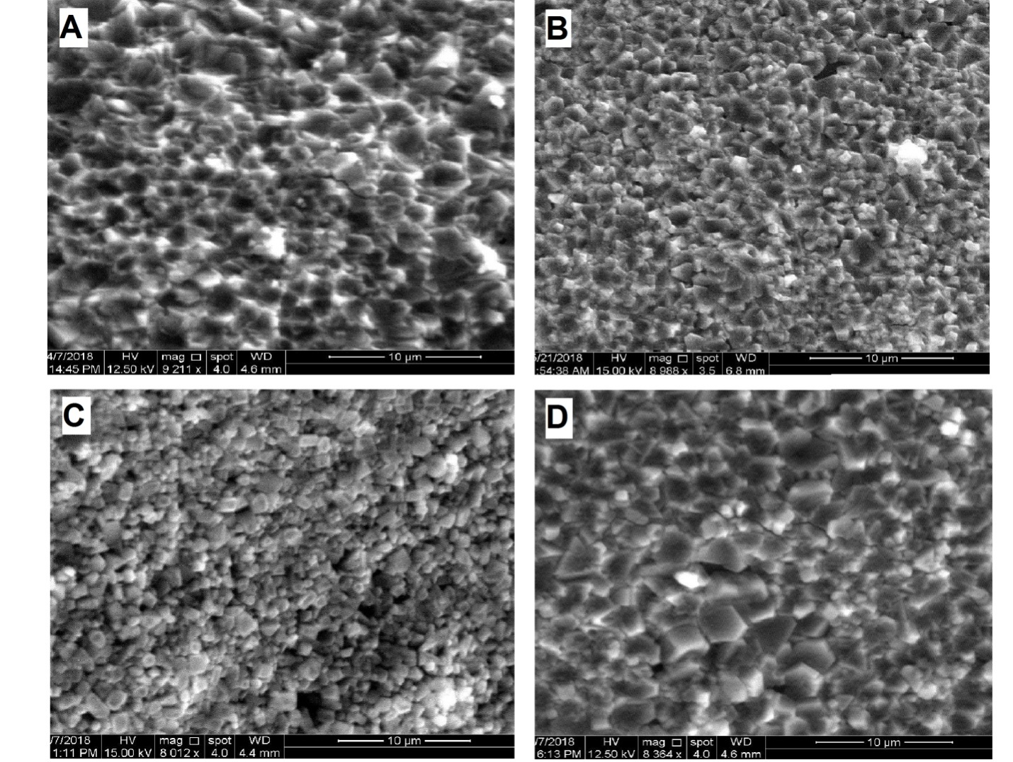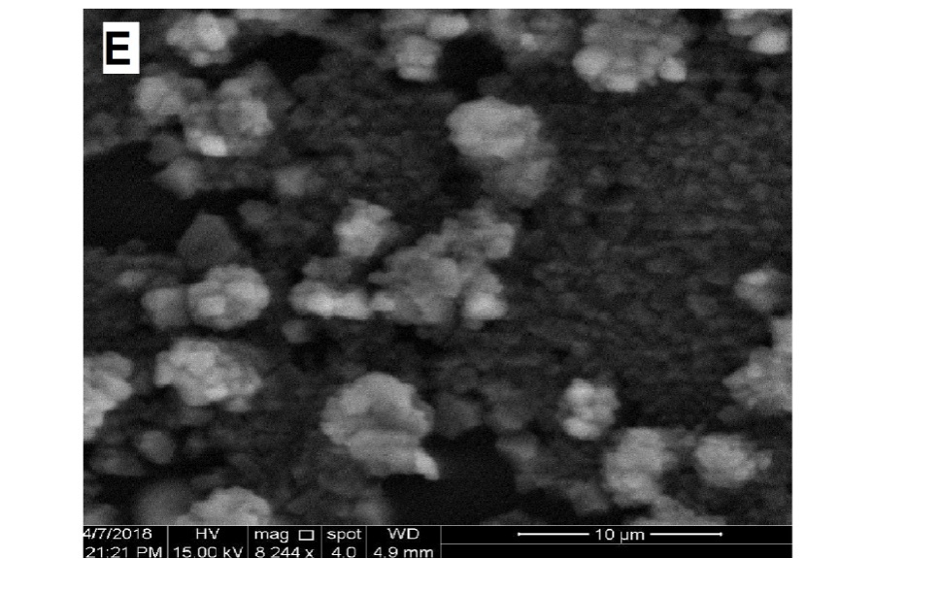

**Fig. 1.SEM images of (8988X): (A) for (PAA-CMC), (B) for 1.5 wt% MgO, (C) for 3 wt% MgO, (D) for 4.5 wt% MgO,(E) for 6 wt% MgO.**

**3.2The D.C electrical properties(PAA-CMC-MgO) nanocomposites**

Figure 2show the variation of D.C electrical conductivity of PAA and CMC as a function of magnesium oxide (MgO) nanoparticles concentrations. From this figure, the electrical conductivity increases with the increase of the concentration of (MgO) nanoparticles.The increase of conductivity can be explained as follows: at low concentration, the MgO nanoparticles are located in separated groups or cluster inside the polymer. when the concentration reaches to 6 wt.% for (PAA-CMC-MgO) nanocomposites, the nanoparticles form a continuous network inside the polymer .This network has paths where charge carriers are allowed to pass through the paths that have low electrical resistance[15].

**Fig.2.Variation of D.C electrical conductivity with MgO nanoparticles concentration for (PAA-CMC-MgO) nanocomposite.**

Figure 3 show that the electrical conductivity increases with increase of the temperature of (PAA-CMC-MgO) nanocomposite this is means that resistance decrease with temperature increased. The explanation of this behavior is the polymeric chains and impurity ions act as traps to make charge carriers moving by hopping process this attributed to two main reasons the first one is electronic charge carriers and the second, mobility of these charges [15].

**Fig.3.Variation of D.C electrical conductivity with temperature for (PAA-CMC-MgO) nanocompoites.**

Figure 4 show the variation of Ln D.C electrical conductivity with inverted absolute temperature of nanocomposites. The activation energy was calculated by using Eq. 2 as shown in figure (5).The activation energy has high values at low concentration because of the creation of local energy levels in the forbidden energy gap which act as traps for charge carriers while at high concentration it has low values as a result of the increase of local centers and the formation of a continuous network of MgO nanoparticles that contains paths inside the nanocomposite and allows charge carriers to pass through [16].

**Fig.4.Variation of D.C electrical conductivity with inverse absolute temperature of (PAA-CMC-MgO) nanocomposites.**

**Fig. 5.Variation activation energy for D.C electrical conductivity with nanoparticles MgO wt.% concentration for (PAA-CMC-MgO) nanocomposites.**

**3.3 The A.C electrical properties of (PAA-CMC-MgO) nanocomposites**

Figure 6 shows the variation of the dielectric constant of (PAA-CMC-MgO) nanocomposites with the frequency. From this figure the dielectric constant decrease when increasing the frequency.This is attributed to decreasing of space charge polarization with respect to the total polarization .The ionic polarization reacts slightly to the variation in the field frequencies compared with electronic polarization; this is because the mass of ion is greater than that of the electron. The electrons respond even to the high frequencies of the field vibrations. The low mass of electron makes the electronic polarization was the only type of polarization at higher frequencies, this makes the dielectric constant approximately constant for all samples at high frequencies. The dielectric constant is increased with the increase of the weight percentages of magnesium oxid nanoparticles which due to increase the charge carries numbers which is increase the electrical conductivity of polymer matrix [17,18], as shown in figure (7).

**Fig. 6.Variation of the dielectric constant of (PAA-CMC-MgO)nanocomposites with frequency.**

**Fig. 7. Variation ofDielectric constant with concentration of magnesium oxide nanoparticles wt.% for (PAA-CMC-MgO) nanocomposites.**

figure 8 shows the dielectric loss as a function of the frequency of (PAA-CMC-MgO) nanocomposites. From this figure the dielectric loss decreases with increase thefrequency.This is due to the mobile charges within the polymer backbone.This is attributed to the decrease of the space charge polarization contribution when increasing the frequency. While the dielectric loss increases with the increasing of the concentration of MgO nanoparticles due to increase the numbers of electrons in nanocomposites [19], as shown in figure (9).

**Fig. 8 .Variation of the dielectric loss with frequency for (PAA-CMC-MgO) nanocomposites.**

**Fig. 9. Variation of Dielectric loss with concentration of magnesium oxid nanoparticles wt.% for (PAA-CMC-MgO) nanocomposites.**

Figure 10 show the variation of A.C electrical conductivity of nanocomposites as a function of frequency.As shown in figure the A.C electrical conductivity is increased with increase of the frequency, this is due to the space charge polarization. While the conductivity is increasing with the increase of the MgO nanoparticles concentration due to increase charge carrier density in polymer matrix [20], as shown in figure (11).

**Fig. 10.Variation of A.C electrical conductivity with frequency for (PAA-CMC-MgO) nanocomposites.**

**Fig. 11.Variation of A.C electrical conductivity with magnesium oxid nanoparticles wt.% concentration for (PAA-CMC-MgO) nanocomposites.**

**3.4Piezoelectric Sensors Application**

Figure 12 shows the variation of electrical resistance for (PAA-CMC-MgO) nanocomposites with different pressure. The electrical resistance decreases with increase the pressure because the crystal contains of multiple interlocking domains consisting of positive and negative charges.These domains are symmetrical within the crystal. When a stress is applied to the crystal this symmetry is broken so the domains will reorder themselves in order to restore the symmetry, through this process, will generate a current and the resistance will be decreased [21].

**Fig. 12.Variation of electrical resistance with pressure.**

**4. Conclusions**

1- Scanning electron microscopy (SEM) shows the surface morphology of the (PAA-CMC-MgO)nanocomposites films many aggregates or chunks randomly distributed on the top surface, homogeneous and coherent.

2- D.C electrical conductivity for (PAA-CMC-MgO) nanocomposites increased with increasing of temperature and magnesium oxid nanoparticles wt.% concentration.

3- Activation energy of (PAA-CMC-MgO) nanocomposites decreases with increasing of themagnesiumoxidnanoparticles wt.% concentration.

4- The dielectric constant, dielectric loss and A.C electricalconductivity of (PAA-CMC-MgO) nanocompositesincrease with increasingof the MgO nanoparticles concentrations.

5- The dielectricconstant and dielectric loss of(PAA-CMC-MgO) nanocompositesdecreasewith increase thefrequency, while A.C electrical conductivity increases with increase thefrequency.

6- The (PAA- CMC -MgO) nanocomposites have highsensitivity for pressure.

**References**

[1] L. Qian, "Application of Nanotechnology for high performance textiles", College of Textiles ,North Carolina State University, Journal of textile and apparel.Technology and management, Vol.4, No.1, PP.12-23, ( 2004).

[2] J.C.Miller, R.Serrato, J.M.Represas-Cardenas and G.Kundahl ,"the handbook of nanotechnology", Published by John Wiley and Sons, Inc., Hoboken, New Jersey, part 1, USA, (2005).

[3] M.A.Habeeb and L.A.Hamza, " Structural, Optical and D.C Electrical Properties of (PVA-PVP-Y2O3) Films and Their Application for Humidity Sensor ", Journal of Advanced Physics, Vol.6, PP.1-9, (2017).

[4] N.Taniguchi. " Proc.of International Conferenceon Precision Engineering", Tokyo,Part II, Japan Society of Precision Engineering, PP.18-23 (1974).

[5] K.E.Drexler,"Engines of Creation,The Coming Era of anotechnology", New York:Anchor Press/Doubleday ( 1986).

[6] K. A. Shenoy, "Effects Of Multi-Wall Carbon Nanotubes On The Mechanical Properties Of Polymeric Nanocomposites", M.Sc. Thesis, Department of Mechanical Engineering and the faculty of the Graduate School of Wichita State University (2008).

[7] M. A. Habeeb and W. K. Kadhim, " Study the optical properties of (PVA-PVAC-Ti) Nanocomposites",Journal of Engineering and Applied Sciences, Vol.9, No.4, PP.109-113, (2014).

[8] A. Hashim, M. A. Habeeb, A. Khalaf and A. Hadi, " Synthesis of Novel (Polymer Blend-Titanium Carbide) Nanocomposites and Studying their Characterizations for Piezoelectric Applications ", Journal of University of Babylon, Pure and Applied Sciences, Vol.26, No.6, (2018).

[9] I.R .Agool, K.J .Kadhim and A .Hashim, "Synthesis of (PVA-PEG-PVP-MgO) nanobiomaterials and their application", Advances in Environmental Biology,Vol.9,pp.101-106, (2015).

[10] M. A. Habeeb and W. K. Kadhim, " Study the Electrical properties of (PVA-PVAC-Ti) Nanocomposites",Australian Journal of Basic and Applied Sciences, Vol.8, No.10, PP.316-322, (2014).

[11] H. Frohlich, "Theory of Dielectric", 2nd ed., Oxfored University press, (1988).

[12] S. Ravichandran, "Synthesis and enhanced mechanical properties of nano Zinc Oxide in Polyvinyl alcohol and polyvinyl pyrollidone composite film" Int. J.NanoDimens. 4(2): 153-159,(2013).

[13]E. Sheha, H. Khoder, T.S. Shanap,M.G. El-Shaarawy and M.K. El Mansy," Structure, dielectric and optical properties of p-type (PVA/CuI) nanocomposite polymer electrolyte for photovoltaic cells" University of Benha, Egypt ,123(13):1161-1166,(2012).

[14] N. K. Abbas, M. A. Habeeb and A. J. K. Algidsawi, " Preparation of ChloroPenta Amine Cobalt(III) Chloride and Study of Its Influence on the Structural and Some Optical Properties of Polyvinyl Acetate " , International Journal of Polymer Science, Vol.2015, pp.10, (2015).

[15] J. Gurland,"Electrical resistivity", J. Polym. Plast.Technol. Eng. Vol. 19, No.1, pp. 21-51, (1982).

[16] M.A.Habeeb, A.Hashim, A.Khalaf and A.Hadi, "Fabrication of (PVA-PAA) Blend-Extracts of Plants Bio-Composites and Studying Their Structural, Electrical and Optical Properties for Humidity Sensors Applications", Sensor Letters, Vol.15, No.7, PP. 589-596, (2017).

[17] C. Chiteme , S. Lowther and S. Harrison , " Science of Polymer", Vol. 43, PP. 3273-3287,(2005).

[18] M. A. Habeeb, "Dielectric and optical properties of (PVAc-PEG-Ber) biocomposites", Journal of Engineering and Applied Sciences, Vol.9, No.4, PP.102-108, (2014).

[19] A. Hashim,M. A. Habeeb,A. Hadi and W. Hadi, "Fabrication of Novel (PVA-PEG-CMC-Fe 3 O 4 ) Magnetic Nanocomposites for Piezoelectric Applications",Sensor Letters, Vol.15, No.12, PP. 998-1002, (2017).

[20]G. Shui , J. Hu , M. Qiu, M. Wei , D. Xiao and J.Chinese chem." Study of Dielectric Properties For (Calcium Oxide-poly-vinyl alcohol)Composites", letters, Vol. 15 , No. 12 , pp1501-1504, (2004).

[21] M. A. Habeeb, A. Hashimand A.Hadi,"Fabrication of New Nanocomposites: CMC-PAA-PbO2Nanoparticles for Piezoelectric Sensors and GammaRadiation Shielding Applications",Sensor Letters, Vol.15, N0.9, PP.1-6, (2017).