***CONSTRUCT DESIGN DEVELOPMENT OF ROBOTIC HAND ACTUATOR FOR AFTER STROKE PATIENT REHABILITATION***

**YV Gunawan Alim  
MTE.15.15.0159**

**Abstract**

*This research is analyzing about construct design development of robotic hand actuator for after stroke patient rehabilitation, implementation for people paralyzed due stroke, the function is to move a paralyzed hand member. It consists of 12 actuators, and for each actuator is driven by DC Motor idependently. This actuator is movements by the other normal hand of stroke patient with symmetrical movements, asymmetry as well some physiotherapy movements that have been programmed. This integration control is carried out using an Arduino Uno microcontroller. The testing of the instrument was carried out by simulating the Simulink test, simulation testing using Proteus and direct testing of the prototype. This research have some diviations, and it happen because of the inertia of tools and equipment. This finding of this research is that robotic hand is quite heavy, and some movements that arise is not according in the program, and the response time is take a long time.*

## Introduction

Public Health Service in Indonesia are good enough. Increasing expectancy of life and decreasing number of mortality can be an indicator of good public health service in a country.[1] Even though the healthy services are good enough, the modern lifestyle can bring the negative impact of health too. Demands to work hard, not healthy food behavior and the longer of stress can cause cardiovascular disease, this one is stroke. It becomes a dilemma if the number of stroke in Indonesia increases from year to year Stroke is the number 3 killer disease in Indonesia. In addition, post-stoke sufferers experience new problem.[2] From motor, cognitive and psychological disorder.

The prevalence of motor paralysis of the hands causes limited sufferers to do their daily movement activity, and it is more unfortunate if sufferers are still productive and become a source of economic family. Several kinds of movements are needed to maintain the integrity of joint function and muscle strength. Special equipment is also needed to help physiotherapy, for the example: barbell, games, traction, etc.[3]

Post-stroke sufferers who experience paralysis require special equipment to support their mobilization, like wheelchair, walker walking AID, canes and etc. But, the equipment for moving fingers and hands not available and has not been applied to patient post-stroke paralysis.[4]

Based on the problems that are formulated above, the objectives of this research are formed as followings:

1) Design and make prototype robotic hand based Arduino Uno using resistance sensors for post stroke rehabilitation.[5] 2) Analyze the result of prototype ATR based Arduino Uno and resistance sensors to be used to more the ATR Prototype with symmetry and asymmetry movements of the other normal hand of the post-stroke patient.

And also, this research have the benefits too, as followings; 1) Give hope to after stroke patient in the future. 2) Hopefully the ATR prototype 12 can be develop by the other researcher who are interested in the field of mechatronics and robotics. 3) Practice and programming microcontroller can be realized in real mechanical movements using ATR Prototype 12.

## Background

1. Permanent Magnet DC motors

Permanent Magnet DC motors use permanent magnet to produce magnetic field. The advantages is permanent Magnet DC have small size and relatively large power capacity than the other electric motors. And, the setting of motor DC is not complicated, has a constant magnetic strength and stable.[6]

Rotor is consists of wire coil which is mounted on the armature, the side of the coil is connected to the commutator segment through brush that made with carbon, the electricity flowed to motors commutator. And the objective of commutator is to cut and pair the electricity who flow to the every segment of rotor.

1. Actuator

The mechanism of actuator electromechanical can be explain as follows, the source of rotary power of DC motors is converted into a straight motion.[7] The axis of DC motors connect with reduction gear, the purpose is to duplicate the torque on the threaded shaft and decrease the rotational speed of the threaded shaft on the actuator. If the bolt is turned clockwise (CW) against the nut that is not be moving, the bolt will move forward and preferably. If the bolt is turned counterclockwise (CCW) the bold moves backward. The DC motors torque is change to push and pull. The push and pull will movements to actuator mechanics.[8]

1. Motor Drive

The user of electric motors for some need using is need control. The control of motor operation is adjust to the nature of load. There’re several types of electric motor control; starting, motor stopping, braking, speed regulation, and reversing motor rotation. (1) Starting, starting in an electric motor is to bring the rotor rotation from a stop state into nominal speeds.[9] Then, starting to a permanent magnet DC motors requires a large enough electric flow. (2) Braking, is the opposite of starting. Braking is to stop the rotation of the motor from its nominal speed to zero or stop speed. (3) Speed regulation, motor speed regulation is required for certain load properties, have the certain types of load also requires a speed that changes every certain period time. The greater the motor voltage, the higher rotor rotation. This is different from the magnetic flux at the motor poles. [10]

(4)Forward Reverse, the motor controller is Clockwise (CW) and counter clockwise (CCW). The motor turn reversal setting is required for certain loads, such as lift aircraft, electric trams, conveyor, and actuators. The Rotor reversing direction of rotation can be done by reversing the motor voltage polarity. Reversing direction of rotation of the rotor can also be done by reversing the polarity of motorpoles. There is 2 control system reversal of the direction (1) H-Bridge system, use 4 power transistor, the disadvantages of this system is because using 4 power transistor, so the series is more complicated. And the advantages using this system is, source voltage not using flashlight. 2 pieces of transistor is connect with positive energy, and the other 2 pieces is connect with negative energy. (2) Half H-Bridge system, the advantages is using voltage source with a flashlight tap and 2 power transistor, and the series is simple, and the disadvantages is using source voltage requires a middle tap.

1. Microcontroller

Microcontroller is an integrated circuits with small size and have function as controllers.[13] Almost same with a small computer, it has a CPU to process the data, a series of data storage memories and input output. The center of microcontroller run by CPU, there is 2 important components as follows; Control Unit (CU) and Aritmatica Logic Unit (ALU). The function of control unit is to fetch, decode, and execute a program stored in memory.[14]The other function from unit controller is to generate andregulate control signal that needs to synchronize operation, instruction of the program and the control of information on the data bus and address bus. Aritmatica unit and logic is a part who connect with Aritmatica operation such as addition, and subtraction. Aritmatica unit also can manipulate data logic such as operate AND, OR and compare. Microcontroller have a several component, such as; (1) Address bus, is channel a number of address channel paths between the device and computer (2) Data Bus, is a channel to input and output data in microcontroller system (3) Control Bus, is for synchronization microcontroller operation using outside assembly operations (4) Memory, save data or program (5) RAM, Random Access Memory, memory can be read and write (6) ROM , Read Only Memory, memory only can be read (7) Input / Output, to connecting the microcontroller with another output equipment microcontroller.

1. Arduino program

The Arduino module can be function after being programmed by computer. The software of Arduino programming is called Arduino Idea. The Arduino Uno program is common referred to as Sketch, the program is an instruction or code to set the Arduino program. After is created, the program is saved with a file name.The basic program of Idea Arduino is quite a lot, such as question if, for and while, function string and aray also function of numeric.[15]

## Proposed System Modul

The Study refers to research in the field of robotic hands to movements and rehabilitate patient after stroke. Researches design and make actuator devices, there are several control system that have been tested by previous researches, as follows; with biomechanics, myogram signals, gyro accelerometers, force acting actuation and normal symmetry movements with the other normal hands.

This research will be discuss is a normal symmetry control system with the other normal hand.

Flex Sensor is installed on each actuator. In the normal hand, flex sensor also glue with the tape. Placing the flex sensor on every each fingers, wrist, elbow and shoulder. The output of flex sensor is resistance, and the resistance change according to the bending angle. The greater of bending angle, the value of resistance is smaller and vice versa. The output each of flex sensor on the actuator and the output of each flex sensor on the other normal hand is connect to the comparator input. And every each of flex sensor is connected to 1 comparator. For 12 actuator have 12 comparator units are needed. And by the comparator the resistance of each pair of flex sensors is compared. If there is a difference in resistance, the motor will move the actuator. The flex sensor on the actuator changes in value, it will stop moving when the resistance of the flex sensor pair is equal. The actuator movement can go forward or backward for adjustment. So, that the paralyzed hand moves in sync with the other normal hand. [18]In the other conditions, the symmetric movements is become a barrier and difficulty for the user. For example, walking and the other movements who needs a balance for hands, to anticipate this thing needs the stop moving (stop movements from actuator), also needs the asymmetric, and need the on-off button and inverting circuit. Design and device robotic hand actuator who create by researches is already carried out trials and tested for many times.

1. Architectural Design

The Design of ATR Prototype implementation in patients



Gambar 3. 1ATR Mechanical



Gambar 3. 2ATR Lefthand side view

1. Software Design

Encoding of ATR Prototype actuator, sensor and drive for program preparation

1. ATR modeling with Simulink

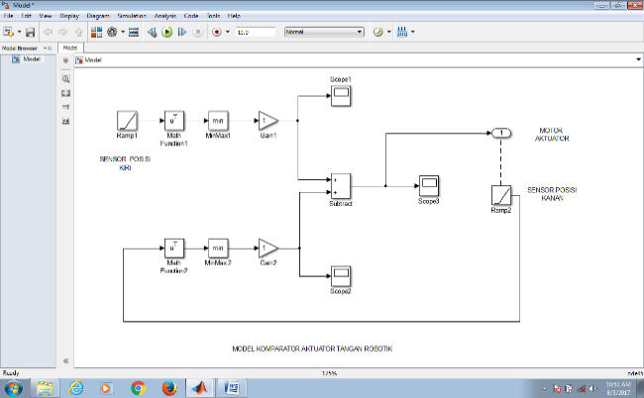

AAATR Simulink illustrated with a block diagram, an each of block have a different function and parameter. There are 2 of the same string, where every each of string is divide into several block. The output voltage of the string group after being strengthened with the output voltage string 2 after being strengthened then becomes the function input of parameter block with equivalent parameter function on the Simulink.

Gambar 3. 3ATR modeling with simulink

The output voltage of each string is installed a scope to see the output signal generated from each string. The output of string 1 is attached 1 scope, and the output of string 2 is attached 2 scope. The output of each string is connected as an input as equivalent of integrator. Output signal from control string is a positive signal, and the output signal from string actuator which is a position sensor is a negative signal. If each signal has same voltage and same time, then the output of the substrate is zero, and the scope of 3 signal is shown flat on the zero line. So, the motor actuator stop at the position desire by the control.

## Testing and Analysis

The test is carried out by (a) each part of the module, such as an actuator, sensor, etc. (b) The functional of the robotic hands (c) trials on patients who have stroke.

1. Functional Testing

Is a testing of prototype function, can be said as a black box testing. Test the function of each components by one by one, like actuators, motors, sensors, and control system. And from testing it can be known the weakness of each component, the control and overall system. Errors can be found and analyzed easily. The equipment that used for testing is; ruler, spring scales and pendulum scales, oscilloscopes, volt meters, ampere meters, stop watch, and laser temperature. The each part who must be tested; thumb, fore finger, middle finger, ring finger, little finger, wrist, elbow, shoulder, and overall ATR.

1. Non-functional testing with Proteus simulator

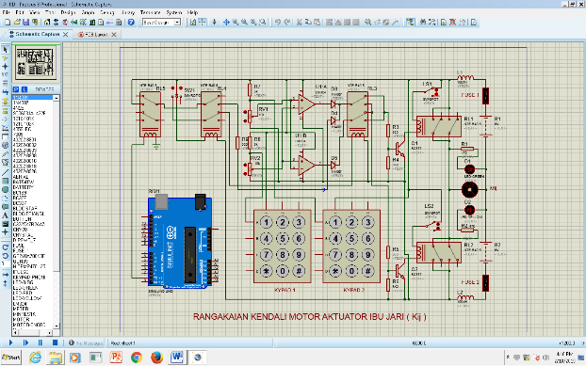Testing of hardware can be simulated using Proteus simulator. Proteus simulator provides software for electronic and microcontrollers. This testing is carried out in detail with each part test. Non-functional test are carried on 12 actuators. And the result review of the test is by pictures and captions. Some material test on the ATR components is follows; (1) Switch over change test (2) sensor resistance change test (3) forward movements actuator motors test (4) Reverse movements actuator motors test (5) Voltage source for symmetry and asymmetry test (6) on-off switch for programmer movements test (7) Accuracy of the system work on source voltage drop test (8) Control testing of the Arduino Uno output pin (9) Connecting and Disconnecting of Arduino Uno test

Some things weakness and imperfections of the actuator system hand robotic can happen in this research. This is caused by several things as follow; (1) system inertia (2) physical load due to the load of robotic actuator equipment (3) user discomfort (4) limited movements (5) friction of metal actuator system on the skin (6) slow response time (7) System stability.

Figure 4. 1Non Functional testing with Proteus simulator

1. Non-functional testing with Simulink

Different with simulation ATR using Simulator Proteus. Simulink, testing can’t display components in detail or clearly. Simulink replaces components with parameter block function equivalent to components. ATS testing using Simulink more accurately. System block diagram illustrate the function of the control system of each actuator. And the one actuator with another actuator is independent. So, using Simulink can be done just using one system of actuator. As a testing material, the system test is using the shoulder actuators, because shoulder actuators is a largest actuators than the other actuators. And the shoulder actuators is raise all equipment and sufferers hand to the top movements. In the Simulink a test is carried out as follows; (1) Reduce the resistance level on the resistance sensor which is replaced by the ramp function ramp parameter block 1 (2) Increase the resistance sensor which is replaced by the function parameter block 1 (3) Decrease response time on function mathematical parameter block function 1 (4) Increase response time to function parameter block 1 mathematical (5) Decrease the integrator function parameter block 1 (6) Increase the integrator function parameter block 1 (7) Reverse integrator function (8) Observe output signal change in scope 1,2,and 3

## Conclusion

1. Conclusion
   * + 1. Robotic hand actuator equipment is quite heavy, so it burdens the motor actuators. Because of that, the lifting force of the elbow, shoulder actuators 1, and shoulder actuators 2 become smaller and can’t lift heavy loads. This robotic hand is quite heavy and is also burdensome when applied to the stroke patient.
       2. The response time is take a long time, especially when calculated from the start time to the end time, the achievement time is even longer
       3. The robotic hand actuator for physiotherapy functions sometimes occurs movement that are not able in the program, and this happen because the reducer gear ratio not large enough, so that elbow actuator can’t hold its own load when the motor is turned off from the electric power source.
       4. The electrical energy requirements for motors is accord with the activity of actuators. If the activity is high, battery will quickly run out
       5. The blackness of the robotic hand actuator, so mechanical movements is always late compared the control side movements.
2. Suggest
3. To lighten the robotic hands, mechanical made with lightweight metal for example like aluminum and titanium. And the DC Motors use lightweight DC motors with big power.
4. The complexity of the electrical cable installation can use common negative, or by placing the control of each of the actuator independently near every each of the actuator.

## References

[1] B. Aceh and B. Aceh, “Oleh Ns . Marlina , M . Kep . , Sp . MB *).”

[2] D. Risk, F. Of, and S. In, “Faktor Risiko Dominan Penderita Stroke di Indonesia,” pp. 49–58, 2015.

[3] K. A. Nugroho, “PENGEMBANGAN ALAT BANTU REHABILITASI PASIEN PASCASTROKE BERBASIS VIRTUAL REALITY,” pp. 45–52.

[4] N. Publikasi, W. R. Pribadi, P. Studi, D. Iii, F. I. Kesehatan, and U. M. Surakarta, “Penatalaksanaan fisioterapi pada pasien pasca stroke hemiparase dextra,” 2015.

[5] S. Kosolapov, “Arduino 37 Sensor Kit First acquaintance.”

[6] M. C. Group, “Permanent Magnet DC Motors,” pp. 193–200.

[7] G. Belforte, G. Eula, A. Ivanov, and S. Sirolli, “Soft Pneumatic Actuators for Rehabilitation,” pp. 84–106, 2014.

[8] A. D. Agrawal and M. A. Chandak, “Animatronic hand,” vol. 1, no. 1, pp. 12–15, 2012.

[9] E. M. Drives, “Lesson Electrical Actuators : DC Motor Drives,” pp. 1–18.

[10] M. Drives, “Permanent Magnet DC.”

[13] J. Warren, *Arduino Robotics*. .

[14] S. M. Last and P. M. Utc, “Arduino Lesson 15. DC Motor Reversing,” 2017.

[15] “30ArduinoProjectsfortheEvilGenius-007174133X-Copy.” .