MICROCONTROLLER APPLICATIONS BASED FUZZY LOGIC CONTROLLER FOR TEMPERATURE ON BREEDING FISH POND carp

Dian Efytra Yuliana¹, Suryani Alifah², Bustanul Arifin³
^{1,2,3} Jurusan MTE, Fakultas Teknologi Industri, Universitas Islam Sultan Agung Semarang Jl. Raya Kaligawe KM 4, Semarang 50112, Indonesia
Email : dianfytra@gmail.com, suryani.alifah@unissula.ac.id, bustanul@unissula.ac.id

ABSTRACT

Carp is a freshwater fish that have economic opportunities to be cultivated. In the maintenance required carp control well to temperatures that are too low can affect the ability of the organism to bind oxygen so stunted. To overcome this, do a system that can keep the working temperature automatically. This tool works on the basis of the readings of the temperature sensor into the ATmega16 microcontroller through ADC port. ADC readings used fuzzy logic control input on the program. Results defuzzification program is used to set the amount received by the circuit pwm solid state relay. Pwm magnitude proportional to the voltage received by the heater, so that the heat of the heater can be set large. The water in the aquarium box (prototype pool) will be in circulation by the pump. This device has a high degree of accuracy in monitoring the temperature inside the pool, while the difference in temperature with the thermometer sensor has an average percentage error with high accuracy level.

Keywords : Fuzzy logic, heater, pompa, AT Mega 16, Solid State Relay

1. Introduction
Carp is a freshwater fish that have economic opportunities to be cultivated. Carp are known as commodity bright prospect, because it has a high selling price growth rate quickly, easily cultivated, the meat is thick enough. This is why the carp get attention and interest by entrepreneurs to cultivate, especially in the village of Kampung Baru subdistrict Tanjunganom, Nganjuk, East Java. Because it is self-employment, carp does not require a large area in pembudidayaanya and usually do disebuah pool size is not too large.
In the maintenance required carp control towards in the water parameters such as the effect of water temperature, oxygen content, pH, and salinity. The importance of some of the parameters that must be maintained its stability is carried out setting any of these parameters ie temperature settings automatically. Farmers cultivating freshwater carp stated that the maintenance of the pond and carp seed, temperature tolerance value for a good maintenance with minimum water temperature of 28⁰C-30⁰C.
Temperatures that are too high can increase the stress on the seed and fish. While the temperature is too low can affect the ability of the organism to bind oxygen so stunted (Sugiarto, 1988).
To maintain the temperature usually done manually. To fit the needs of the growth of carp, it is necessary to monitor the temperature at any time. The way it is less effective and efficient, as it can lead to a waste of energy and time. To overcome this, do a system that can maintain the desired temperature which can work automatically by using fuzzy logic.
2. BASIC THEORY
  - Pembenihan Gurami
Gourami (osphronemous gouramy) is a species of freshwater fish consumption is much-loved by the community and has high economic value. Although known as a slow pertumbuhanya fish, this fish is still known as the belle of fish consumption because the price is quite high (Julius dkk, 2011)
In carp breeding, hatchery operations play an important role in the provision of seeds to be enlarged to the size of consumption. During this time, one of the biggest obstacles in the effort seeding carp in the pond is the high rate of death (mortality), especially of larvae to seed the size of hatchlings results 1cm.
One way around that is by applying the seeding technique by using an aquarium. With this technique, all the seeding stage, ranging from hatchery to nursery to produce seed size of a fingernail can be controlled effectively. However, given the high investment and operating costs required when using an aquarium as a whole, budi daya carp transferred to the pool when the nursery phase. Therefore, even more applicable nursery pond.
Use of water quality is an important factor of success carp hatchery. To provide a means of seeding with the use of aquarium does require a higher investment when compared with pengguanaan pool. However, the results obtained are also advantageous because pengguanaan aquarium sanagat can suppress seed mortality to below 10%. When compared to the hatchery pond, the mortality rate can reach 25%. In fact, the percentage mortality can swelled seed high in bad weather conditions, for example when it rains constantly. Another advantage of seeding with seeds of the aquarium is the growth rate faster than that of pond maintenance.
2.2 Mikrokontroler Atmega16
Microcontroller can be analogous to a computer system that is packaged in a chip. The microcontroller is more than just a microprocessor as already exist or contains ROM (Read-Only Memory), RAM (Read-Write Memory), some Port inputs and outputs, and multiple peripherals such as counter / timer, ADC (Analog to Digital converters), DACs (Digital to Analog converter) and serial communications.
One microcontroller which is widely used today is AVR microcontroller. AVR is RISC microcontroller (Reduce Instuction Set Compute) 8 bits based on the Harvard architecture. In general, AVR microcontroller can be classified into 3 groups, namely families AT90Sxx, ATMega and ATtiny. Basically what distinguishes each class is a memory, peripherals, and features.
As microprocessors in general, internally microcontroller ATmega16 consists of functional units Arithmetic and Logical Unit (ALU), a set of working registers, register and instruction decoder, and timers along with other control components. In contrast to microprocessors, microcontrollers provide the memory in the same shale dengen processor (in the chip).
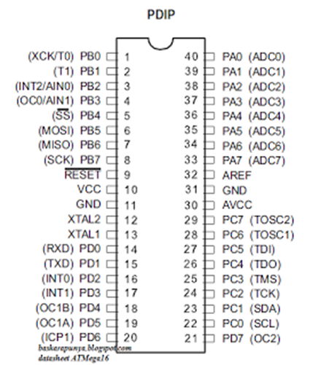
Figure 2.1 Configuring pin ATmega16
  - Fuzzy Logic
Fuzzy logic was first introduced by Prof. Lotfi Zadeh of the University of California at Berkeley, in mid 1960. To calculate an infinite number of gradations between right and wrong, Zadeh developed the idea he calls the classification set of fuzzy sets. Unlike boolean logic, fuzzy logic has a lot of value (Nugroho, 2010). There are some basic concepts that should be known that relate to Fuzzy Logic, as shown in Figure 2.2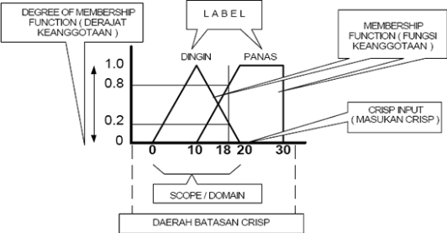
Figure 2.2 The concept of Fuzzy (Nugroho, 2010)

2.2.1 fuzzification
In the fuzzy logic process is first conducted fuzzification process. Where fuzzification process can be described by Figure 2.3
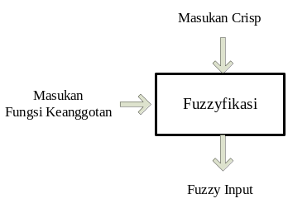
Figure 2.3 The process of fuzzification (Fauzi, 2010)
The first step in the process of transformation of fuzzy logic contains a domain called fuzzification. Put crisp transformed into fuzzy input (Fauzi, 2010). To transform inputs into input crisp fuzzy membership function must first be determined for each input. Once the membership function is determined, fuzzification take input values ​​in realtime, and comparing it with information stored membership function to generate a fuzzy input value.
In the fuzzification process there is some form of fuzzy membership function shown in Figure 2.4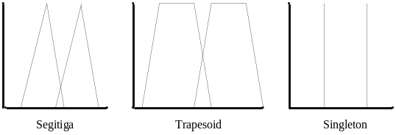
Figure 2.4 Form of Function Keangotaan (Fauzi, 2010)
Membership function to give meaning expressed numerically on each label. Each membership function identifies areas corresponding to the input value label.

2.2.2 Rule Evaluation
The next step after that is fuzzification rule evaluation, we will know how to use the input fuzzy rules are rules to determine the action of the system. Three methods used in performing fuzzy inference system: max method, additive method, or probabilistic methods (Fauzi, 2010).

2.2.3 defuzzification
Input of defuzzification is a set obtained from the composition of the rules, while the resulting output is a fuzzy set of numbers in the domain (Fauzi, 2010). Defuzifikasi a continuation of the rule base. Several methods of defuzzification is:
1. Method of center of gravity / centroid
In this method, the crisp solution is obtained by taking the center point of a fuzzy area, generally defined in Equation 2.1 for continuous variables and equations 2.2 for discrete variables

2. Method bisektor
In this method, the crisp solution is obtained by taking the value of the fuzzy domain that has a membership value of half of the total value of membership in the fuzzy area. Generally written in Equation 2.3
Dimana:
3. Method of maximum mean
In this solution, the crisp solution is obtained by taking the average value of a domain that has a maximum membership value.
4. Methods Reviews largest of maximum
In this method, the crisp solution is obtained by taking the largest value of a domain that has a maximum value of membership is.
5. Method smallest of maximum
In this method, the crisp solution is obtained by taking the smallest value of a domain that has a maximum value of membership is

2.4 Temperature Sensor LM35
LM35 is an electronic component that has a function to change the temperature scale into electrical quantities in the form of voltage. LM35 temperature sensor used in this study in the form of electronic components manufactured by National Semiconductor. LM35 temperature sensor of high accuracy and ease of design when compared with other temperature sensor, LM35 also has a low output impedance and high linearity that can be easily linked with the special control circuits and does not require any further adjustment.
Although the sensor voltage can be up to 30 volts but given to the sensor is at 5 volts, so it can be used with a single power supply with the provision that the LM35 only requires a current of 60μA this means LM35 has the ability to generate heat (self-heating) of the sensor that may cause a low reading is less than 0.5 ° C at 25 ° C.

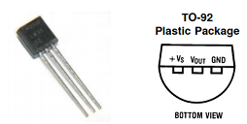
Figure 2.5 Physical Form LM 35 and Pin Configuration (source: http://www.finger.de-web.cc/poel/lm35.pdf)

The image above shows the shape of LM35 looked forward and looked down. 3 pin LM35 shows the function of each pin of which, pin 1 serves as a source of working voltage of LM35, pin 2 or being used as a voltage output or Vout with a working range from 0 volts up to 1.5 volts with an operating voltage of LM35 sensor that can used between 4 Volts to 30 Volts. The sensor output will rise by 10 mV per degrees centigrade in order to obtain the following equation:
VLM35 = Temperature x 10 mV
(Source: http //: www.shatomedia online / lm35.html)

3. RESEARCH METHODOLOGY
3.1 Method of Fuzzy Logic On Breeding Pool Gurami
3.2.1 fuzzification
Fuzzification stage is the stage of the formation of the membership function. Fuzzification divided into two groups, namely fuzzification fuzzification error and delta error. Both pieces fuzzification group is used to add parameters of fuzzy set.
The input value (crisp) fuzzification Error comes from the difference between the value of the desired set point and temperature values ​​displayed by the sensor. As for the error delta fuzzification input values ​​(crisp) derived from the difference between the current error value and the value of the previous error. Mathematically shown in the following equation:
Error = SP -pv ................... ... ...... .. (3.1)
Delta error = e (n) - e (n-1) ....... ... .. (3.2)
Information :
SP = Price Set Point
PV = Price Output at time t
e (n) = Price error at time t
e (n-1) = Price error at time t-1
Enter the fuzzy that error and delta error and for the range of 6 to -6 maksimumya namely because it is assumed room temperature to 300 C so that the maximum error = 36-30 = 6.
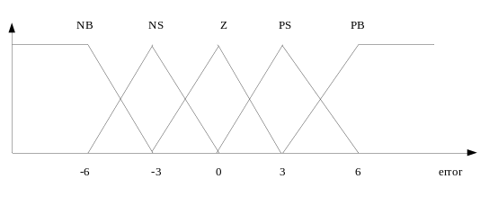 Figure 3.1 fuzzification Value Error
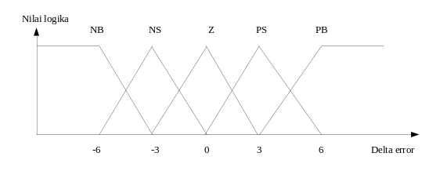Figure 3.2 fuzzification Delta Value Error

3.2.2 Rule Evaluation
At this stage, each output of fuzzification stage in the form of linguistic variable degrees of membership and both of error or error delta will be merged by using rule evaluation. Of rule evaluation will be known variation of the heater overheating Below is Table 3.1 as the level of heat heater:
Table 3.1 Rule Heater
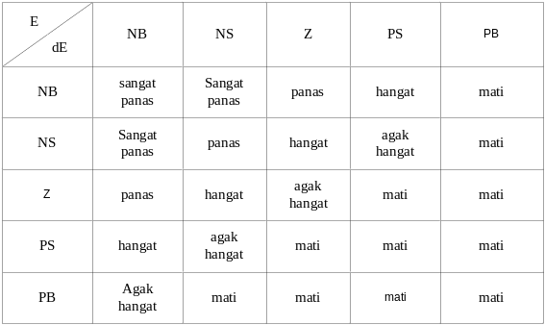
3.2.3 defuzzification
The output of the rule evaluation stage will be used as a rule the most correct and will be multiplied by the value of the degree of membership. The method used in defuzzifikazi is the Center of Gravity (COG) or centroid. Ie the sum of all output membership function which is multiplied by a singleton of each action. From these results later in the average with a total output of fuzzy. Here is the output of defuzzification process is crisp to the heater:
Crispheater = off * (0) + agakhangat * (0) + warm * (225) + heat (250) + very hot (250);
Crispheater = crispheater / (dead + agakhangat + warm + heat + very hot);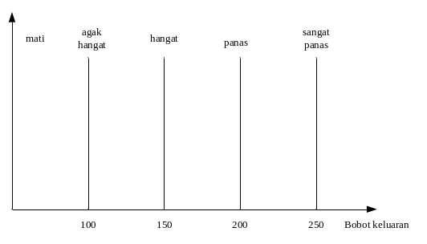 Figure 3.3 Membership Function Output Heater

3.3 Architectural Design
The identification of the system specification requirements made the block diagram so that at the design stage will be adjusted to the temperature controller block diagram of fuzzy logic. The block diagram of fuzzy logic temperature controller is shown in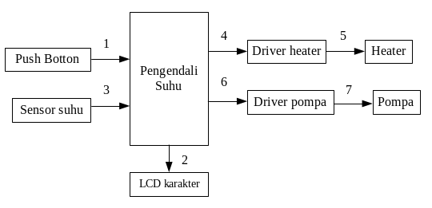
Figure 3.4 Block diagram of the system
3.4 Hardware Design Networks
3.4.1 Minimum System AVR ATmega16
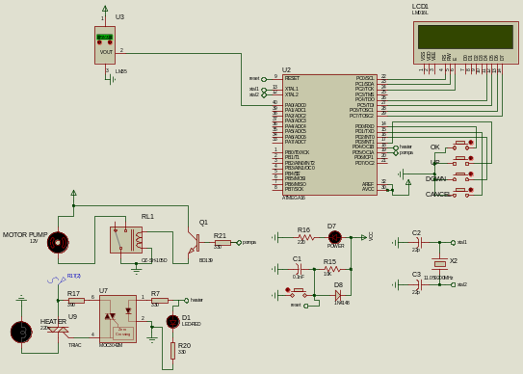 Figure 3.5 Schematic circuit System
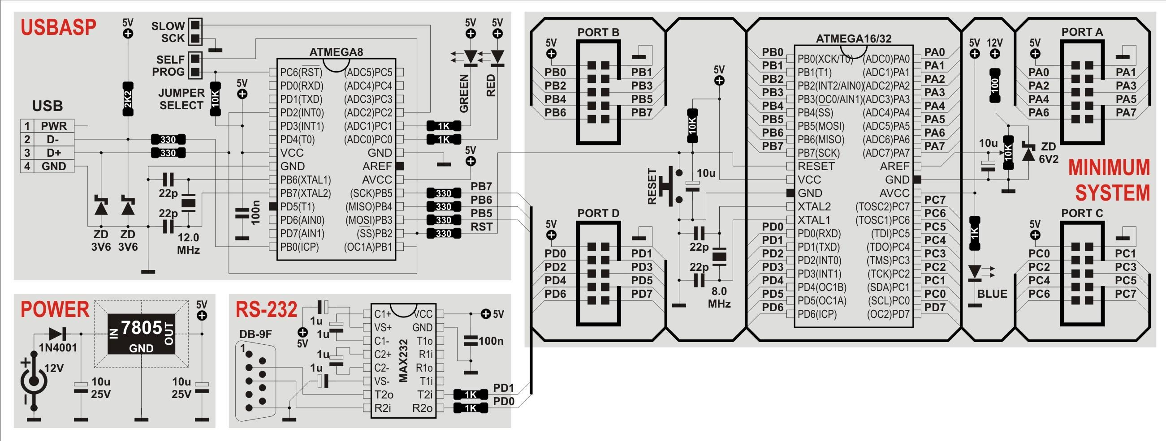
Figure 3.6 PCB Layout PCB Layout Design looks on

At a minimum range of this system, all I / O ports are used for the control circuit in the incubator support. Here the connection pins on the microcontroller with other circuits.
1. Pin A.0 functioned as an ADC for sensor circuit LM35
2. Port C is connected to a series of LCD
3. D.0-D.3 PIN is used for push button as an input pin 2 of the circuit for setting the menu system.
3.1 PIN D.0 Up button, as a function of the desired add value sp
3.2 PIN D.1 Down button, a function to reduce the value of the desired sp
3.3 PIN D.2 Cancel button, a function to repeat the command to enter the set point value
3.4 PIN D.3 Ok button, as a function of the command that is run sistem
3.5 Pin D.4 OCR1A driver circuit is connected to the pump
3.6 Pin D.5 namely OCR1B connected to the heater driver circuit.
Figure 3.6 is a system circuit schematic and PCB layout design 3.7 image looks on.
3.4.2 The series of LCD
Viewers on Climate control system uses a renderer module liquid crystal (LCD) with high brightness levels. This module is a module dot matrix liquid crystal renderer with controllers in it. This controller has a ROM / RAM character generator in it and display data RAM. All display functions are controlled by instructions. EL-1602A is a Matrix LCD Module configuration with 16 characters and two lines with each character is formed by 8 pixel rows and 5 columns of pixels (1 pixel row last is the cursor).
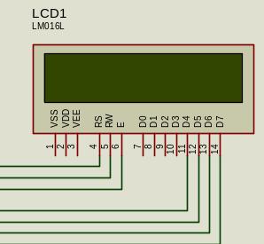
Figure 3.7 The series of LCD

3.4.3 The temperature sensor circuit
The series of temperature sensors that are used in controlling the temperature of the pool (aquarium) The nursery is used to detect detect LM35 temperature pool. LM35 used were 1 piece. The working principle of the LM35 LM35 itself is an accurate temperature sensor IC, the output voltage is linear and in units of Celsius, it can be seen on the scale of the voltage rise 1oC 10mVolt to rise. LM35 can sense the temperature in the range from -55ºC up to 150ºC, with increases in voltage. Pin + Vs of LM35 is connected to the power supply, GND pin is connected to ground and pin analog voltage Vout which produces an ambient temperature sensing result is connected to Vin (+) of the ADC pin PA.0 on ATmega16.
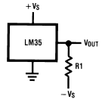
Figure 3.8 Temperature Sensor Networks
3.3 Design Software
Design software used to create a program that is CodeVision AVR microcontroller C language compiler using C. Furthermore, the program is stored in the data memory and program memory. Designing software is done by creating a flow diagram (flow chart) first. Then the program was made by following the flow diagram (flow chart) that have been made. Workflow process software used in such Figure 3. 9
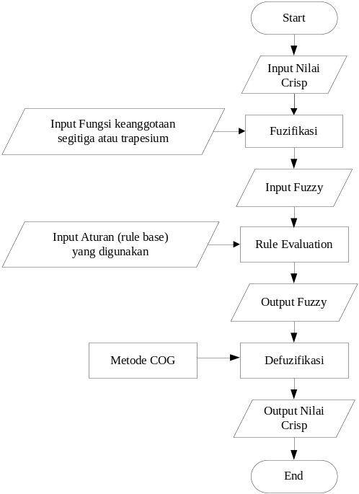
Figure 3.9 Flowchart Software Tool
4. RESULTS AND DISCUSSION
A. Testing LCD series
Tests on the LCD series is performed to determine whether the LCD can work as expected. Tests carried out by software to display characters on each row and column of the LCD. It aims to check whether there is damage to the LCD. While the program code used on the page appendix
.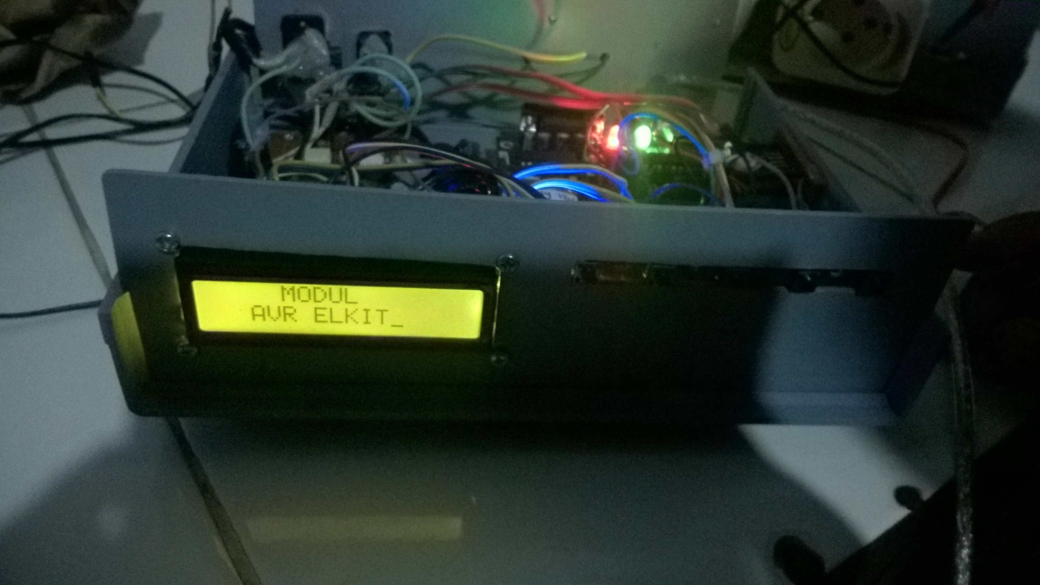
Figure 4.1 Testing LCD series
Figure 4.1 shows that the circuit is functioning as expected writer LCD where each column and row of the LCD is capable of displaying the characters have been given through the program
B. Testing Temperature Sensor
Based on research that has been done, the measurement data obtained temperature sensor value is read and converted into degrees Celsius on LCD display of the digital thermometer as a comparison. The test data is shown in Table 4.1

Termometer (⁰C) | Temperature Sensor (⁰C) | Difference | Error (%)
21 | 20,9 | 0,1 | 0,48
22 | 21,9 | 0,1 | 0,45
23 | 22,9 | 0,1 | 0,43
24 | 23,9 | 0,1 | 0,42
25 | 25,3 | 0,3 | 1,20
26 | 26,3 | 0,3 | 1,15
27 | 27,3 | 0,3 | 1,11
28 | 28,3 | 0,3 | 1,07
29 | 29,3 | 0,3 | 1,03
30 | 30,3 | 0,3 | 1,00
31 | 31,3 | 0,3 | 0,97
32 | 32,3 | 0,3 | 0,94
The average error |  |  | 0,85

Table 4.2 is the result of a comparison between the temperature sensor with a digital thermometer to get the value of the error of the temperature sensor that has been made. Based on Table 4.2 it can be seen that the average value of the temperature difference between the percentage of 0.85% and the level of precision (accuracy) on a series of temperature sensors is calculated by the equation:
The precision (accuracy)
= 100% - Average percentage error - average
= 100% - 0.85%
= 99.15%
Thus, the accuracy of the temperature sensor circuit of the thermometer in the market amounted to 98.15%.
4.1 Testing Overall System
System testing conducted to determine whether the system can work properly. This test refers to the temperature setting on the prototype pool (aquarium box). System testing is done in a miniature aquarium with aquarium box shape in the form of beams with a length of 31.4 cm, 18.5 cm wide and 31.4 cm high.
Tests carried out using a digital multimeter temperature for comparison. At thermometer placed above the water in the tank, while the sensor device is also placed above the water in the tank Table 4.2 shows the test data of the entire system is designed.

Table 4.2 shows the test data of the entire system is designed.

5. Conclusion
No. | The temperature value in digital multimeter temperature  (ºC) | Temperature Value On Display | Output
No. |  | Temperature Value On Display | Pompa |  | Heater
No. |  | Temperature Value On Display | On | Off | On | Off
1 | 27 | 27 | √ | - | √ | -
2 | 28 | 28 | √ | - | √ | -
4 | 29 | 29 | √ | - | √ | -
5 | 30 | 30 | √ | - | √ | -
6 | 31 | 31 | √ | - | √ | -
7 | 32 | 32 | √ | - | √ | -
8 | 33 | 33 | √ | - | - | √
9 | 34 | 34 | √ | - | - | √
10 | 35 | 35 | √ | - | - | √
5.1 Conclusion
Based on data analysis and discussion conducted in this study can be concluded as follows ::
a. LM35 temperature sensor can work well this is because the temperature sensor is connected to a microcontroller capable of measuring temperatures with a percentage error rate of 0.85%% towards digital multimeter readings of temperature as a comparison, or calibrator
b. Fuzzy Logic can be used as a good control on the design of the monitoring system and temperature control in the pond of carp-based Fuzzy Logic. This is because the heater can be well controlled and the desired temperature is almost stable at temperatures specified set.
5.2 Suggestions
Here are some suggestions that can be considered for further refinement of research ::
a. Security system needs to be added as a warning sign to mark the excess heat and heat shortages
b. Temperature sensors need to be added at some point in the prototype pool (aquarium box) to determine the temperature equalization in the pond well

BIBLIOGRAPHY
[1]. Andrian K, Iwan S, Sumardi, Pengendalian pH Air dengan Metode PID pada Model Tambak Udang. Universitas Diponegoro. Transmisi, 14, (4), 2012, 120. [1]
[2]. Mohamad Agung, Dwi SA, Bambang SK, 2016. Rancang Bangun Teknologi Pengatur Kualitas Air pada Pembudidayaan Ikan Lele. Procedings Seminar Nasional Teknik Elektro (FORTEI 2016) Departemen Teknik Elektro UNDIP, 19 Oktober 2016.
[3]. Fadillah Nufinda Rachman. 2012. Rancang Bangun Sistem Monitoring dan Pengendalian Suhu pada Inkubator Bayi Berbasis Fuzzy Logic. Universitas Airlangga.
[4]. Winoto, Ardi. (2010). Mikrokontroler AVR ATmega8/32/16/8535 dan Pemrogaman dengan Bahasa C pada WinAVR. Bandung: Informatika Bandung.
[5]. Julius TS, Riski MH, Prasetya B. (2011). Usaha Pembenihan Gurami. Jakarta:Penebar Swadaya.
[6]. www.alldatasheet.com

