MIMO Printed Dipole Antenna for Wimax Network Usage Application

Suzanzefi

Irawan Hadi Ciksadan

R.A Halimah Thussyadiyah

[Susanzepi82@yahoo.com](mailto:Susanzepi82@yahoo.com)

[sholihin@polsri.ac.id](mailto:sholihin@polsri.ac.id)

**Abstract**. Standard wimax have 2 versions : IEEE 802.16-2004 and IEEE 802.16d. this comprehension also supported by Orthogonal Frequency Division ultiplexing on Physical Layer. OFDm provide wireless DSL technology where broadband cable is not available. Wimax 802.16e use Standard OFDMA Technic. It provide the support for nomadic and mobility service also known as WiMAX phone. Wimax is a wireless broadband technology that have an improvement on WI - FI and UMTS.One of the devices that is needed in the technology is the antenna. The technique used is the MIMO technique. MIMO technique uses multiantene or more than one antenna from both the transmitter and receiver sides. The design and realization of the antenna in this paper is used for 5G devices in the future that work at a frequency of 5.4 GHz - 5.6 GHz. Antenna simulation shows that the planned working frequency is between 5.4 GHz to 5.6 GHz, has a Return Loss of -20.007 dB, VSWR ≤ 2, which is 1.2216, 414 MHz bandwidth, gain of 3.898 dB, impedance of 50.00 Ohm, Omnidirectional radiation pattern. From the design and analysis, this antenna can be used as a 5G technology antenna for the future.

1. Introduction

Wimax provide wireless broadband and mobile terminal in a large geographical area. Wimax 2012 version is providing data rate up to 40Mbit/s and the 2011 version which support speed data up to 1Gbit/s. For stable station, Wimax system use OFDM on Physical layer. Therefore we need an Innovative effort to set up layer system that can help the development of telecommunication sector in the future. The superiority of this research is to help the development of telecommunication sector extensively, it is including the Wimax network. Standard wimax have 2 versions : IEEE 802.16-2004 and IEEE 802.16d. this comprehension also supported by Orthogonal Frequency Division ultiplexing on Physical Layer.OFDm provide wireless DSL technology where broadband cable is not available. Wimax 802.16e use Standard OFDMA Technic. It provide the support for nomadic and mobility service also known as WiMAX phone. Wimax is a wireless broadband technology that have an improvement on WI - FI and UMTS.

Fixed WiMAX and Mobile WiMAX. Fixed WiMAX based on Line of Sight (LOS), the condition of the frequency is between 10 – 66 GHz, while Mobile WiMAX based on Bon-Line of Sight (NLOS), where the frequency condition is work between 2 – 11 GHz. For the 802.16e standard, there are MAC layer and PHY layer, but in this research, the emphasis is only for the PHY Layer. PHY Layer for WiMAX phone with IEEE 802.16e standard have the FFT size (FFT dot with OFDMA), it have variant range 1,6 – 5 km at 5Mbps on 5MHz BW channel, support 100 km v/hour. Multi-input multi-output (MIMO) technology is popular as an important technology to reach the enhancement of all the wireless communication capacity. It work as a transmitter and receiver on antenna, it can reach the space multiplexing on MIMO system from the information transmission [1].

The FCC (Federal Communication Commission) proposed a new channel (FCC 15-138) for wireless broadband frequencies from 28 GHz, 37 GHz, 38 GHz and 64-71 GHz bands which are the frequency bands targeted by researchers for future 5G applications [2].  
Considering the important role of antennas in wireless communication, this research will be designed, simulated and realized an antenna capable of working at 5G frequencies of 5.6 GHz in the future. This study discusses the design, simulation, and measurement of the printed MIMO antenna dipole on the 5.6 GHz frequency, the simulation design process uses CST Studio 2016. The simulation results can be done from VSWR = 1.2216 and Gain value = 3.898 dB.

1. Supporting Theory

*2.1 Wimax*

WiMAX is for Worldwide Interoperability for Microwave Access, it’s a Broadband Wireless Access (BWA) technology which have a high speed access with wide range. WiMAX is an evolution from previous BWA technology with more interesting feature. Beside it can give the high speed data, WiMAX is also a technology with open standard. WiMAX also can do the communication even with different vendor (not proprietary). With the high speed data (up to 70MBps), WiMAX can be applicate to broadband connection.

In General, WiMAX device consist with BS on the base side and CPE on the subsribers side. But there also an add on device such as Antenna, cable, and accessories.

Wimax Device consist :

- Base Station (BS)

- Subscriber Station (SS)

- Antenna

*2.1.1 Frequency Spectrum of WiMAX*

All of the technology that based on frequency, the successful of WiMAX is depend on the conformity and availability of the frequency spectrum. Wireless system recognize two kind of frequency band, licensed band and unlicensed band. Licensed band require licensed and authority from the regulator. When the operator earn the licensed band, it also get the exclusive right to organize the service in specific area.

Unlicensed band does not require licensed while using it, every people can use the frequency with free in all of the area. WiMAX forum set 2 main frequency band on certification profile for fixed WiMAX (band 3,5 GHz and 5,8 GHz), while for Mobile WiMAX, it set 4 frequency band on profile system release-1, there are 2,3 GHz, 2,5 GHz, 3,3 GHz and 3,5 GHz.

In general, there some alternative frequency for the WiMAX technology that suitable with worldwide frequency map. From that alternative, 3,5 GHz frequency become the majority for the fixed WiMAX in some country, mostly for the country in Europe, Canada and Middle – East, Australia and part of the Asia. While the frequency majority for mobile WiMAX is 2,5 GHz.

Frequency issue of fixed WiMAX on 3,3 GHz band evidently is only appear in the Asian country. This is related with the use of 3,5 GHz band for the satellite communication, similarly in Indonesia. 3,5 GHz band in Indonesia used by Telkom satellite and PSN to provide the IDR service and TV broadcast. Therefore if we use the together between the sateliote and BWA on the 3,5 GHz Frequency, it will create the interference potential, especially onj the satellite.

*2.1.2 The Work of WiMAX*

WiMAX station connect to public network with fiber optic, macro wave link cable, or PP (point to pint) connectivity high way known as blackhaul. Base stationserve the customer station or known as CPE (Customer Premise Equipment) using PMP connectivity which NLOS or LOS. This connection known as last mile, WiMAX is ideal if it using the PMP antenna NLOS to connect the residential customer or business customer to the base station. Customer station usually serve the building (Residential or business) with cable or wireless.

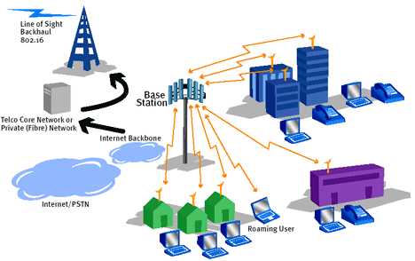

Fig.1 Wimax Netorks

*2.2 Orthogonal Frequency Division Multiplexing*

OFDM is a transmission technic that use some of orthogonal frequency. On this day, OFDM become the standard and being operated in Europe, exactly on DAB (Digital Audio Project) project, and also used on HDSL (High bit rate Digital Subscriber Lines; 1.6 Mbps), VHDSL (Very High Speed Digital Subscriber Lines; 100 Mbps), HDTV (High Definition Television) and Radio communication.

After that, modulation is done to each of sub carrier. This modulation is to be form as BPSK, QPSK, QAM or other, but that three technic is usually done to OFDM, and then the signal that already modulated is being applied into Inverse Discrete Fourier Transform (IDFT), to make the OFDM symbol. The use of IDFT may allocated the orthogonal frequency, it will be explained further. After that the ODF symbol will be converted into a serial and the signal will be sent.

The other main character from OFDM is strong to face the frequency selective fading. With OFDM technology, even though the communication path have a frequency selective fading characteristic (where bandwidth from the channel is smaller than the bandwidth from the transmission that causing the low power from the frequency), but each of sub carrier from the OFDM system only have the flat fading.

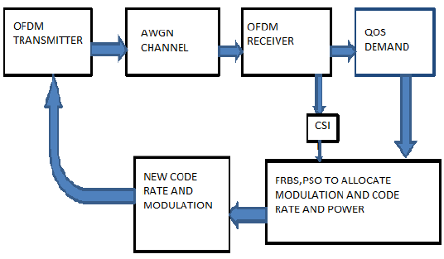

Fig.2 Basic of OFDM



……………………………………..……………… (1)

*2.3 Additive White Gaussian Noise*

AWGN is a noise terme which distributed with normal and average value = 0, also upgraded the signal level. Noise in the channel can destroy the signal, because the signal that received by the receiver is not same with the signal that has been sent. Signal that receive with the time range 0 < t < T, is the signal which send with noise, where there is no reducer on it channel. S(t) is signal that send and n(t) is channel noise as a random zero mean Gaussian. Theoretically the channel usually modeled with the distribution of Gaussian with mean = 0 and characteristically as a statistic with tight function or probability density function Gaussian.

r(t) = S1(t) + n(t) , 0 < t < T ……………................................................. (2)

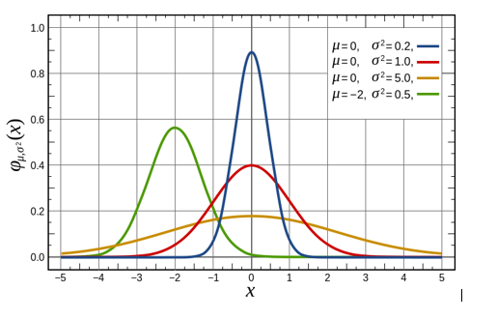

Fig.3 PDF Gaussian with δ = 1

*2.3.1 Fading Channel*

Fading is a decrease and fluctuation of signal power on receiver. Fading cause the condition where signal can not be recognized on a signal return process into information. Fading can be categorized in two parts, Large scale fading which related with path loss and small scale fading which related with plural line between transmitter and receiver.

Table 1 classified some of pictures about small scale fading phenomena. If we look on how the impact from the channel on the time dimension and the frequency that impact the signal then the channel can be grouped into flat fading channel and frequency selective fading channel. While if we look on how fast the signal that being sent is transformed and how fast the transform from channel to channel, the channel can be grouped into the fast fading channel and the slow fading channel.

On this last task, it will focus on analyzed the small scale fading,especially the slow fading. Slow fading can be assumed the fading reducer is not changing at least for one period of transmission symbol.

**Table 1.** S*mall-scale* fading Clasification

|  |  |  |
| --- | --- | --- |
| Smal Scale Fading | Based on Multipath Time Delay Spread | Flat Fading :   * BW signal < BW koheren * Delay spread < periode symbol |
| Based on Doppler Spread | Frequency Selective Fading :   * BW signal > BW koheren * Delay spread > periode symbol |
| Fast Fading :   * Doppler spread >> * Coherence time < perode sysmbol * Channel variasion beter than quickly from baseband signal |
| Slow Fading :   * Doppler spread << * Coheren time > periode sysmbol * Channel variasion beter than slow from signal baseband |

*2.4 Bit Error Rate*

On the telecommunication sector, the error ratio is the amount of bit, element, character or block that receive with the total amount disbanding of bit, element, character or block that sent along the time interval. The most common ratio is Bit Error Ratio (BER). The example of BER is the amount of bit error that receive divide with the amount of bit that sent. Usually BER described with the the connection between BER and SNR or BER with Eb/No.

*2.5 Multi Input Multi Output*

The demand of high data rate and the service quality of wireless communication system is trigger the new technology to develop the spectrum efficiency and the improvement of line quality. This thing can be reach with multi antenna on the receiver and transmitter, this technic known as Multiple Input Multiple Output (MIMO). The work principle of MIMO is to duplicate the information signal that transmitted to improve the communication ability and reduce the error that occur on the transmission channel.

To earn the space diversity, it using some of antenna in the different space location that showed by picture 2.8. For example, if we use M antenna to send the signal on transmit diversity and M antenna to receive the signal on receive diversity. The main advantage is its not necessary to add time allocation or some frequency to earn the diversity.

The main weakness from space diversity is the fact that different signal need to be given on the independent fading. This means that the antenna should be placed on certain range so that the signal that receive or transmit through the channel which not correlate. If the antenna placed without distance settings, therefore the antenna will through the same line. So that the copy of the signal that received will correlate, and the diversity advantage will not be earned.

1. Results

MIMO technique uses multiantene or more than one antenna from both the transmitter and receiver sides. To design this antenna, use the software which aims to visualize the antenna. The initial design of the antenna uses the values ​​of the antenna dimensions obtained from the calculation results then optimization to get results that are in accordance with the required specifications. The design and realization of the antenna in this study is used for 5G devices in the future that work at a frequency of 5.4 GHz - 5.6 GHz. Antenna simulation shows that the planned working frequency is between 5.4 GHz to 5.6 GHz, where the initial specifications for making this antenna are return loss ≤-10, VSWR ≤ 2, gain ≥3. The simulation results in a Return Loss of -20.007 dB, VSWR ≤ 2 that is 1.2216, 414 MHz bandwidth, gain of 3,898 dB, impedance of 50.00 Ohm, Omnidirectional radiation pattern. From the design and analysis, this antenna can be used as a 5G technology antenna for the future. The dimension values ​​generated in theoretical calculations include Patch Length (Lp) 11.75 mm, Patch Width (Wp) 16.53 mm, Groundplane Length (Lg) 21.35 mm, Groundplane Width (Wg) 26.13 mm, Feeding Length (Lf) 8.26 mm and Supply width (Wf) 4.2 mm. Whereas in the CST simulation Patch Length (Lp) 12.16 mm, Patch Width (Wp) 18.2 mm, Groundplane Length (Lg) 28.16 mm, Groundplane Width (Wg) 32.45 mm, Feeding Length (Lf) 8.26 mm and Feeder Width (Wf ) 3.1 mm. It can be seen from the results of calculations and simulations that it produces dimension values ​​that are not much different.

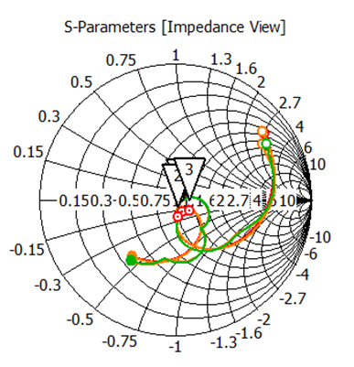

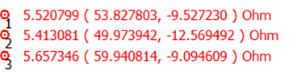

Fig. 4 S-Parameters Antenna MIMO Printed Dipole

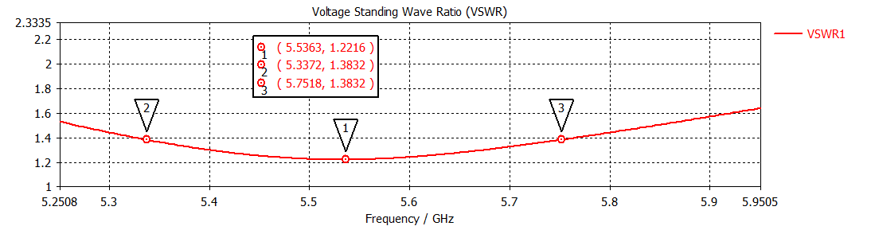

Fig. 5 VSWR Antenna MIMO Printed Dipole

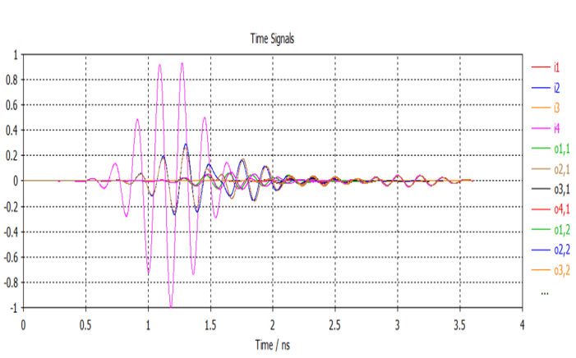

Fig. 6 Port Signal Antenna MIMO Printed Dipole

1. conclusion

In making this dipole MIMO antenna, it can be concluded that the use of the antenna frequency value that is used can affect the value of the antenna dimension, where the greater the frequency value is used, the smaller the antenna dimensions, the smaller the frequency value produced will be even greater. From the results of the antenna parameter calculation in simulation, the VSWR ≤ 2 is 1.2216, the return loss is -20.007 dB, 414 MHz bandwidth, gain 3.898 dB, impedance 50.00 Ohm, Omnidirectional radiation pattern.

References

1. Mai Tran, George Zaggoulos, Andrew Nix and Angela Doufexi, “Mobile WiMAX: Performance Analysis And Comparison with Experimental Results”, in proceeding 68th IEEE Vehicular Technology Conference, 21-24 September, 2008.
2. Jeffery G. Andrews, Arunabha Ghosh, Rias Muhamed, “Fundamentals of WiMAX: Understanding Broadband Wireless Networking”, Prentice Hall, 2007.
3. Theodore.S.Rappaport, “Wireless Communications: Principles & Practice”, 2nd ed., Prentice Hall, 2001.
4. Kobayashi, H. Fukuhara, Hao Yuan, Takeuchi Y,” Proposal of single carrier OFDM technique with adaptive modulation technique”, in proc. IEEE conference on Vehicular technology, 2003.
5. J.El-Naijar, B.Jaumard, C.Assi, “Minimizing Inter-ference in WiMAX/802.16 basded networks with Centralized scheduling”, in proc.
6. IEEE standard 802.16-2005, IEEE standard for Local and Metropolitan Area Networks-Part16: Air Interface for Fixed and Mobile Broadband wireless Access system, Feb 2006.
7. Daniel W. Bliss, Keith W. Forsythe, and Amanda M. Chan, MIMO Wireless Communication, Lincoln Laboratory Journal, Vol.15, No.1, 2005,pp.97-126.
8. T. L. Marzetta, "Massive MIMO: An Introduction," in Bell Labs Technical Journal, vol. 20, no. , pp. 11-22, 2015.
9. Franco De Flaviis, Lluis Jofre, Jordi Romeu, and Alfred GrauMultiantenna Systems for MIMO Communications, Morgan & Claypool Publisher, 2008.
10. X. Liu, M. Bialkowski and F. Wang, "Investigation into the Effects of Spatial Correlation on MIMO Channel Estimation and Capacity," 2008 4th International Conference on Wireless Communications, Networking and Mobile Computing, Dalian, 2008, pp. 1-4.
11. A.A. Asaker,R.S. Ghoname, A.A. Zekry, Design of a Planar MIMO Antenna for LTE-Advanced, International Journal of Computer Applications (0975 – 8887),Volume 115 – No. 12, April 2015.
12. I. K. Sokhi, Ramesh R and Usha Kiran K, "Design of UWB-MIMO antenna for wireless applications," 2016 International Conference on Wireless Communications, Signal Processing and Networking (WiSPNET), Chennai, 2016, pp. 962-966.
13. M. I. Ahmed, A. Sebak, E. A. Abdallah and H. Elhennawy, "Mutual coupling reduction using defected ground structure (DGS) for array applications," 2012 15 International Symposium on Antenna Technology and Applied Electromagnetics, Toulouse, 2012, pp. 1-5.