STATCOM Application for Reactive Power Compensation
On Distribution of PLTMH Curug Muncar

Ghoni Musyahar¹, Muhammad Haddin², Arief Marwanto³
^{1,2,3}Magister Teknik Elektro, Universitas Islam Sultan Agung
Jl. Raya Kaligawe KM 4 Semarang
e-mail: ¹sultandigitalpicture@ymail.com, ²haddin@unissula.ac.id, ³arief@unissula.ac.id

Abstract
Among the sources of electrical energy used in remote areas or mountains are using micro hydro power plants (PLTMH). The problem that arises in PLTMH Curug Muncar is the low power factor (cos ϴ) in the distribution. The power factor measured in users / consumers is an average of 0.7. One of the reasons for this is the varied type and use of loads on consumers, resulting in waste reactive power.
As an alternative solution to these problems is to compensate for electrical power to load changes that are very dynamic. From the reference, it shows that the Static Synchronous Compensator (STATCOM) is the most effective reactive power compensator.
STATCOM is located in the position between the generator and load variation. The reactive power settings by STATCOM occur by comparing the value of the terminal voltage between STATCOM and the system. If the STATCOM voltage is lower than the system, the STATCOM will absorb reactive power from the system. Meanwhile, if the STATCOM voltage is higher than the system, the STATCOM will generate reactive power to the system
STATCOM is able to compensate for reactive power with a very fast time (0.3 seconds) and is able to absorb or provide reactive power to the distribution. STATCOM is able to change cos θ from 0.7 to 0.93. The repaired voltage is close to the given Vrms value.

Keywords: PLTMH. STATCOM, Reactive Power

1. Introduction
Electricity needs now have become a basic necessity of human life. From urban centers to remote villages all need electricity. Almost all equipment related to the lives of many people use electricity. From the education, communication to social activities sectors. For people who live in urban areas or areas that have electricity distribution lines, this is not a problem. However, if a community lives in a remote or mountainous area that is not yet difficult to reach by the distribution of electricity, they must strive to provide their own source of electricity. Among the sources of electrical energy used in remote areas or mountains are using micro hydro power plants (PLTMH).
The problem that arises in PLTMH Curug Muncar is the low power factor (cos ϴ) in the distribution. The power factor measured in users / consumers is an average of 0.7. This is caused by the distance between the power plant and the load of 2 kilometers and the type of load on the consumer. With a power factor (cos ϴ) which is low as a result consumers cannot use electric power optimally and electricity bills are also expensive.
A bad power factor results in enormous reactive power consumption. Provision of quality electric power is a very important point of concern, because electrical equipment from the community must be used optimally. Household industries that use even electric motors (such as sewing and furniture services) are endeavored by people who use electric power for electric devices that need good power quality (eg computers and printers for printing businesses). Then it is necessary to improve the power factor (cos ϴ) from 0.7 to 0.9. With a good power factor, it can save on reactive power usage, consequently the electricity cost becomes cheaper.
Reactive power compensators have the ability to regulate the amount of power and can be flexible depending on the load that works. One of the most effective efforts to reactive power compensation model today is Static Synchronous Compensator (STATCOM).
Several previous studies have been conducted on the use of STATCOM, among others, STATCOM provides better overshoot attenuation compared to SVC and Fixed Capacitor Banks based on the results of a steady-state and dynamic response study. The comparison of the comparative results of voltage fixes between Fixed Capacitor, SVC, and STATCOM, best in comparative voltage repairs is STATCOM [1]. STATCOM for renewable energy sources that have been modeled and simulated shows the performance of the versatile Icosϴ control algorithm. From the results of the analysis and also proven that the Icos adalah controller modification is a viable solution for reactive power compensation, increased power factor is supported by the real power of renewable energy sources. STATCOM is an effective interface unit between renewable energy sources (RES) and grid, which acts as an important link for effective power compensation [2]. This study discusses the application of STATCOM to compensate for the reactive power in the development of the 500kVA Curug Muncar PLTMH power plant.

2. Research Methodology
2.1. Reactive Power Problems
Excessive reactive power in the system causes a decrease in the performance of electricity transmission. This is because reactive power will affect the amount of real power that will be used by the load and also determine the amount of power factor that works on the system. The greater the value of the reactive power, the lower the value of the power factor and the real power sent to the load, which in turn will reduce system efficiency.
Reactive power compensator or known by another name VAR compensator is defined as equipment that serves to regulate the amount of reactive power, to improve the operation of the AC power system. Reactive power compensators are classified as Flexible AC Transmission System (FACTS) equipment which is capable of operating flexibly in regulating power flow in the transmission system. This means that by using a reactive power compensator, reactive power can be controlled at the load[3].
S (false power) = V.A (1)
P (real / active power) = S cosϴ (2)
Q (reactive power) = S sinϴ (3)

2.2. Static Synchronous Compensator (STATCOM)
STATCOM is categorized as a new technology in the field of reactive power compensators. In the series STATCOM uses a converter circuit consisting of power electronic components and also energy storage media for reactive power settings. On the control side, STATCOM has implemented a digital control scheme that enables optimal performance and application of control techniques with higher operating values.
Besides having a function to control reactive power, STATCOM also has a function in improving other parameters related to electricity quality. For example, the STATCOM is able to produce a small harmonic value and a controlled AC voltage value as output. The value of this output voltage can control the values ​​of reactive currents using the switching method. In addition, STATCOM can function to compensate for several other problems such as flicker, impedance of the transmission system, and phase difference. [4]

In the single line diagram above, it can be seen that the STATCOM is located in the position between the generator and load variation, which functions as a compensatory power to load variations.

2.3. STATCOM Working Principle
The reactive power settings by STATCOM occur by comparing the value of the terminal voltage between STATCOM and the system. If the STATCOM voltage is lower than the system, the STATCOM will absorb reactive power from the system. Meanwhile, if the STATCOM voltage is higher than the system, the STATCOM will generate reactive power to the system. With this arrangement STATCOM is able to compensate for the amount of reactive power that is present in the system.
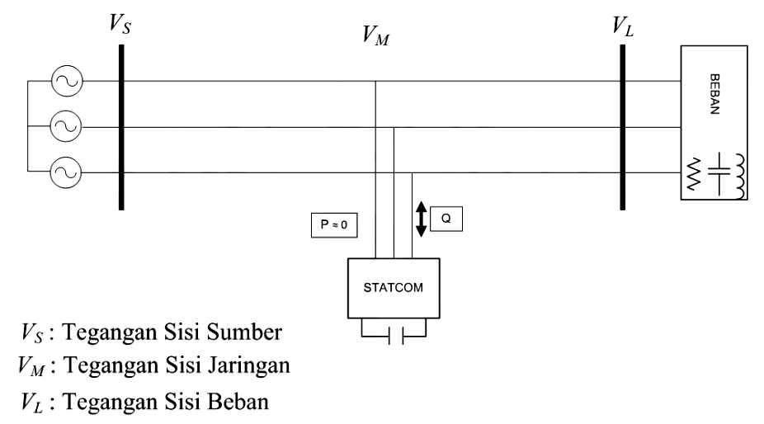
Load
Vs : Source side voltage
V_{M :} Distribution side voltage
V_{L :} Load side voltage

Figure 1. Block of the STATCOM Diagram [4]

STATCOM is controlled by the PWM method, with the main voltage control parameters being the phase angle (a) and the modulation index (m). This method will set the AC voltage on the STATCOM terminal by keeping the Vdc value fixed.
In the STATCOM control process, the current control loop and voltage control loop are used in determining the signal for the switching process. The current control loop will produce output in the form of phase difference (α) which is used to regulate the duration of pulse generation. While the voltage control loop will produce a reference value for the reactive power current (iq *) used to be one of the inputs in the current control loop. Both of these controls use the Proportional-Integrator (PI) control algorithm or a combination of Proportional-Integrator-Deferenceator (PID).
In the process of designing and implementing a control system, it is necessary to measure the system voltage and current values ​​at work. This is used as a basis in determining the STATCOM control process that works in real time following changes in system conditions. The signal is then processed in a simpler and more easily controlled form using the d-q transformation or α-β transformation technique. Which of these input signals is also used to determine the magnitude of the phase angle and frequency used in the control process. This process is carried out using the Phase-Locked-Loop (PLL) method. Then at the end of this process a signal will be generated to determine the control gate switching. Through the control of the switching gate, the voltage on the DC side and STATCOM terminal can be adjusted to allow reactive power control in the system.
In general, the flow of the STATCOM control process can be seen in Figure 2.

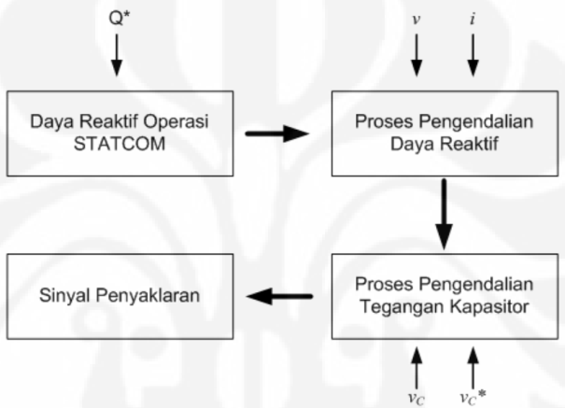
Reactive power of STATCOM operations

Reactive power control process

The process of controlling capacitor voltage

Transmission signal

Figure 2. STATCOM control process flow [4]

The flow explains the STATCOM control process simply. The amount of reactive power value that works on the system will be used as input for determining compensation value at STATCOM. The process of controlling reactive power will then be carried out by entering the voltage and current parameter values ​​of the system. In the next stage, the process of controlling the capacitor voltage is also carried out using the input voltage value of the capacitor on the system and the specified capacitor voltage. By combining between the control of reactive power and voltage of the capacitor, it will then be used to determine the transmission signal. This switching signal functions in the arrangement of the converter circuit to determine the amount of STATCOM voltage for reactive power settings.

2.4 Research Model
The model of the research can be seen in Figure 3 which includes the Generator, distribution channels, STATCOM and load variations.

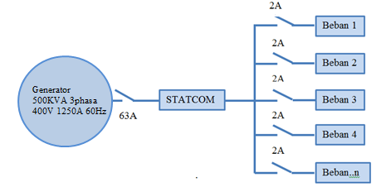
Load. ..n
Load 4
Load 3
Load 2
Load 1
Figure 3. Research model

In simple research about the application of STATCOM for compensation for reactive power can be explained through a flow diagram in Figure 4.

Start

Determine the Research model
like Figure 4.

Specify parameters:
-Capacitor (F)
- Power Generator (KVA)
-LCR channels
-STATCOM
- Load variation (RL)

Simulate

No Yes

Results:
- Reactive Power (VAR)
- Cosϴ

Finish

Figure 4. Research flow chart

The capacity of the generator is used to determine the parameters of the generator in simulink. The generator parameters are taken from a 500KVA generator and simulated data. The distribution cable used is a type of NYAF with a 25mm cross section, with a track length of 2 km. The generator parameters and distribution cables are seen in Table 1.

Table 1. Parameter generator and distribution cable

Generator | Voltage 400V, 60Hz
Generator | 200Vrms
Generator | 500KVA
Cable | 0,780Ω/km
Cable | 4,1264mH/km
Cable | 0,07751µF

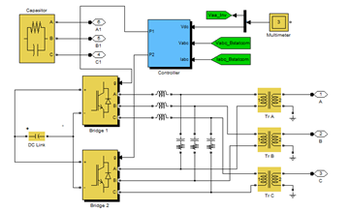
Figure 5. STATCOM series model

The components in the STATCOM are Controller, IGBT, Inductance, Resistor, Capacitor and Transformer. For the parameters shown in Table 2.

Table 2. Parameter STATCOM
Controller | DC Voltage setpoint 200 V
Controller | Vac regulator gains 0,55 2500 (Kp Ki)
Controller | Vdc regulator gains 0,001 0,15 (Kp Ki)
Controller | Currents regulator gains 0,8 200 0 (Kp Ki Kd)
IGBT | Bridge
Inductance | 0,8 mH
R | 0,94mΩ
C | 700µF
Transformator | Nominal Power 500KVA/60Hz 400Vrms

In this research the simulated load is resistive and inductive type. While Variable load is used to provide disturbances in the form of ups and downs of inductive loads with the specified time of disturbance.

Table 3. Loads and load variations

Load | 28.268W 28.672var
Variable load | Arus 10Arms Cos ϴ 0,7
Variable load | Modulation2000Arms 5Hz
Variable load | Modulation time100detik

Model design The overall circuit of Simulink is shown in Figure 6.

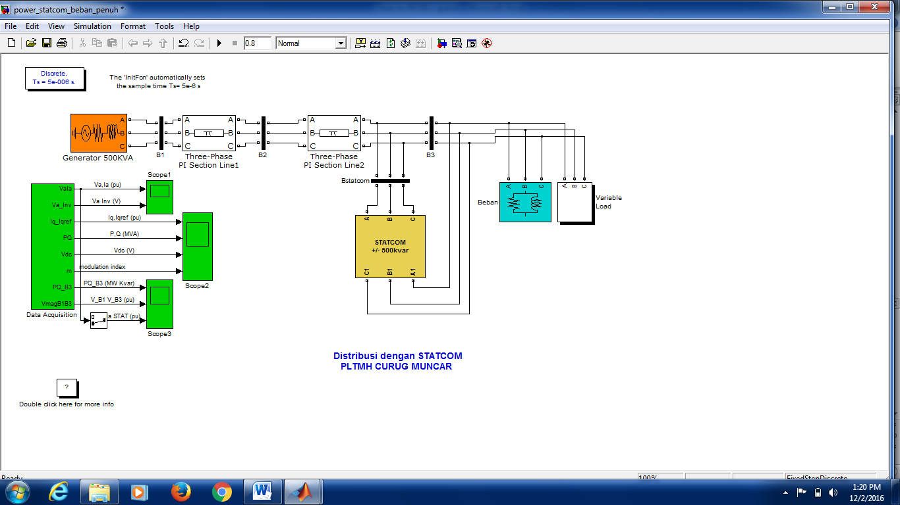
Figure 6. Form of the STATCOM application simulation

3. Results and Analysis
The results of this study are in the form of displaying signals from the scope with load change variables to test the compensation made by STATCOM on reactive power.
The calculation of the capacitor value is used to determine the value of C in the STATCOM parameter.
C = (4)

I₁ = 1,9 A
Consumption is needed in theory if Cos θ 0,9 is:
I₂ = P/V.Cos θ = 351/185x0,9 = 1,7A
Savings:
1,9 – 1,7 = 0,2A = 10,5%
Capacitor value:
Cos θ1 = 0,75 » θ1 = Cos⁻¹ x 0,75 = 41,4°
Cos θ2 = 0,9 » θ2 = Cos⁻¹ x 0,9 = 25,84°
Active Power
P1 = P2 = 263,62W
False Power
S1 = V.I = 185 x 1,9 = 351,5 VA
S2 = V.I = 185 x 1,7 = 314,5 VA
Reactive Power
Q1 = S1.Sin θ = 351,5.Sin 41,4°= 232,45 VAR
Q2 = S2.Sin θ = 314,5.Sin 25,84° = 137,07 VAR
Reactive power that must be eliminated:
ΔQ = Q2 – Q1 = 137,07– 232,45 = - 95,38 VAR
The value of the capacitor used to get the angle (Phi) = 0.9 is:

C = 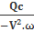 = 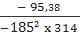 = 8,87x10⁻⁶ F

From the results of the calculation of the capacitor values ​​obtained from measurements of residents' homes is 8.87μF. If there is 80 electricity users, then the capacitor used is worth 700µF (8.87μFx80).
Work Operation Simulation STATCOM aims to determine the design and control capabilities applied in the Statcom series. Simulation is done with a variety of interference modes. Table 4 is the circuit parameters used in the simulation.

Table 4. STATCOM parameters and load variables
Reactive Power Rating Q | 500KVAR
Voltage Vs | 400V 3phase
Inductance LAC | 0,8 µH
Resistor R | 0,1mΩ
Capacitance of Capacitor C | 700µF
Voltage V | 200V
Vout Trasformator Vrms | 400V
Control Model | PWM
Load Variable Flow | 10Arms modulation  2000 5 Hz 100s
Amplitude, Frequency | 2000 5Hz

3.1 Model Description
A Static Synchronous Distribution (STATCOM) is used to regulate voltage on a 400V distribution network. Two distribution lines each along 1 km send power to the load connected on bus B2 and B3. Inductive load of 28,268.24W and 28,672.07VAR is connected to B3 bus. The variable load current is modulated at a frequency of 5 Hz so the power values ​​vary up and down, while maintaining a power factor of 0.7 lagging. This load variation will make it possible to observe STATCOM's capabilities.
STATCOM regulates the B3 bus voltage by absorbing or producing reactive power. This reactive power transfer is carried out through reactance of the leakage transformer by generating secondary stresses. This voltage is provided by a voltage-source PWM inverter. When secondary voltage is lower than bus voltage, STATCOM acts like an inductance that absorbs reactive power. When secondary voltage is higher than bus voltage, STATCOM acts like a capacitor that produces reactive power.
The PWM inverter has a voltage source consisting of two IGBT bridges. This twin inverter configuration produces less harmonics than a single bridge, resulting in smaller filters and improved dynamic responses.
The LC filter is connected to the inverter output. Resistors connected in series with capacitors provide a quality factor at 60 Hz. The 1000 microfarad capacitor acts as a DC voltage source for the inverter.
Electric circuits are discretized using sample time Ts = 5 microseconds. The controller uses a larger sample time (32 * Ts = 160 microseconds).
During this test, the variable load will remain constant and will observe STATCOM's dynamic response to change the source voltage. Modulation of Variable Load is not in service (Modulation Time [Ton Toff] = [0,15 1] * 100> Stop time simulation). The Programmable Voltage Source Block is used to modulate the internal voltage equivalent to 400V.
From the results of measurements during the day (half full load), the average power used through calculations at full load is:

Cosϴ = 0.7 ϴ = 45,570
S (false power) = 252,395VA x 80 (users)
= 20.191,6 VA
= 20.191,6 x 2 (full load)
= 40.383,2 VA
P (active power) = S cosϴ
= 40.383,2x cosϴ
= 40.383,2 x 0,7
= 28.268,24 W
Q (reactive power) = S sinϴ
= 40.383,2x sinϴ
= 40.383,2 x sin 45,57
= 40.383,2 x 0,71
= 28.672,07 VAR

From the calculation results entered into the load parameter block, the results are obtained:
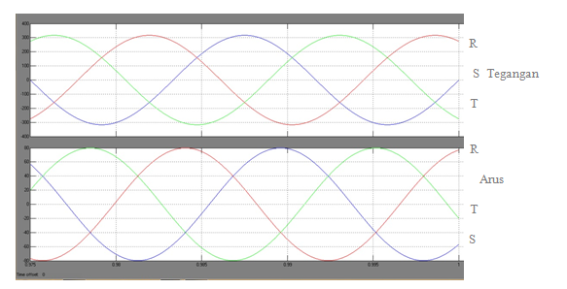
Tegangan

Arus
Figure 7. Comparison of voltage and current signals without STATCOM

In the graph of the simulation results, it appears that the voltage is overtaking (Lagging). The voltage is 317V and the current is 79.81 A. A lagging occurs or the voltage precedes the current by 45.57o, which means cos 45.57 = 0.7. This is due to the amount of inductive load. The 317V voltage is 3 phases which are balanced, then the voltage values ​​for each phase are:

V=317
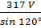 = 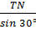
317 V sin30 = TN sin 120°
158,5 v = 0,886 TN
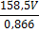
= 183,025V
Voltage with a value of 183,025V means lower than the given rms voltage (200V). Also with a reactive power value of 28,672.07VAR means that it saves less reactive power, because the value of reactive power is greater than the real power.
On an active STATCOM operation the following results will be obtained:

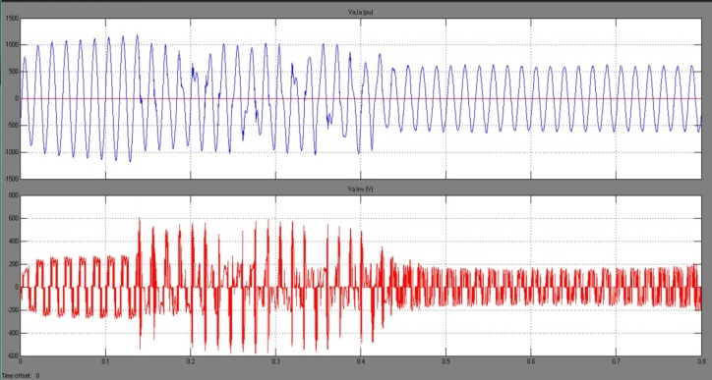
Figure 8. STATCOM power unit and STATCOM inverter voltage

In Figure 8. The trace 1 shows that after a disturbance and fix it for 0.4 seconds STATCOM is able to maintain its day operation of 1.2 pu. In trace 2 proves that the inverter voltage produced by STATCOM is 193.6V. or 3.3% lower than the source voltage (VRMS).
Figure 9. State the capacitor operation of STATCOM in the improvement show in absorbing reactive power and correcting cosϴ.

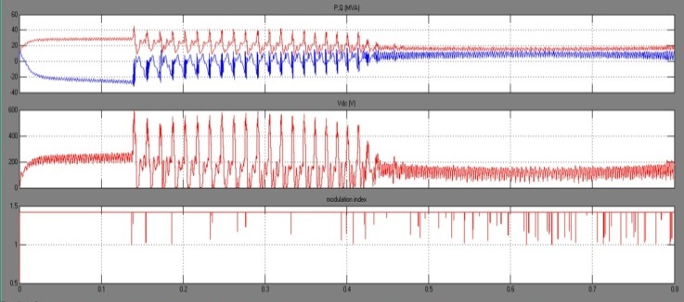
Figure 9. STATCOM capacitor operation

The capacitive operation generated by STATCOM is shown in Figure 10. trace 1 The blue signal is in the negative direction, this means that STATCOM works with capacitive operation by absorbing reactive power.
Transient conditions last around 0.01 seconds, a stable state is reached, so that STATCOM is inactive and does not absorb or provide reactive power to the distribution. Source voltage increases at t = 0.04 seconds, at 12.5% ​​(Vdc = 225V). STATCOM compensates for this voltage increase by absorbing reactive power from the network (Q = + 35 Kvar in trace 1 of figure 11). At t = 0.44 seconds, the source voltage is reduced by 5% from the value corresponding to Q = 0. STATCOM must produce reactive power to maintain a voltage of 1 pu (change in Q from +35 KVAR to -35 KVAR). Note that when STATCOM changes from inductive to capacitive operation, the PWM inverter modulation index increases from 0.56 to 1.4 (trace 3 of figure 9)

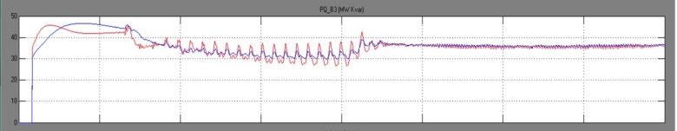
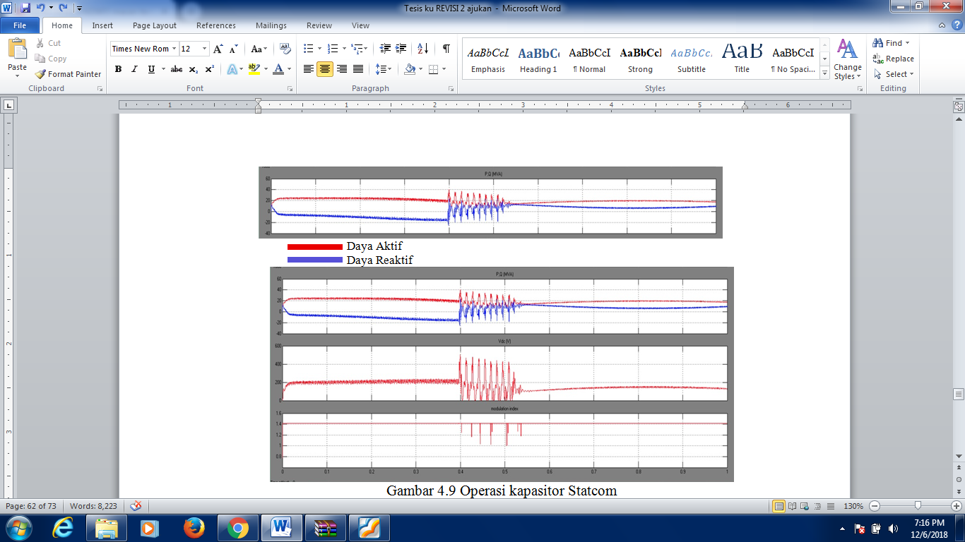
Active Power
Reactive Power
Figure 10. Signal without capacitor operation

The red signal is active power and the blue signal is reactive power. In Figure 10 shows the red and blue signals coincide, meaning the value of active and reactive power is almost the same.
means that there is a waste of reactive power, so compensation is needed.

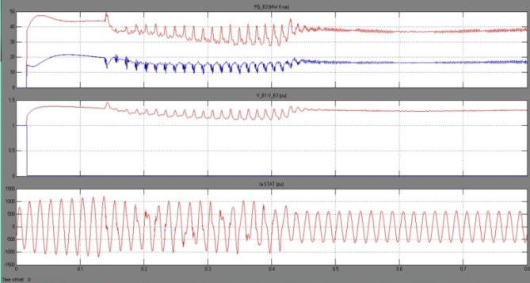
Active Power
Reactive Power
Figure 11. Capacitor operating compensation signal

In Figure 11 trace 1 shows STATCOM has compensated for reactive power to 37,152.54 W and 15,749.44 VAR. The B1 and B3 voltages are stabilized at 1.3pu (Figure 11 trace 2). In trace 3 the STATCOM supply current is able to be stabilized at 600A (pu) which previously caused a disturbance due to the rise and fall of the load, with a change time of 0.4 seconds.

Table 5. Results of reactive power compensation research by STATCOM

Operation | V a,b.c | I a,b.c | S(false)  VA | P(active)  Watt | Q(reaktive)  VAR | cosϴ | sinϴ | Time of Change
Without STATCOM | 183,025V | 79,81A | 40.383,2 | 28.268,24 | 28.672,07 | 0,7 | 0,7
With STATCOM | 193,6V | 38,10A | 40.383,2 | 37.152,54 | 15.749,44 | 0,93 | 0,34 | 0,3 s

4. Conclusion
From the results of the research, STATCOM was able to compensate for reactive power with a very fast time (0.3 seconds). STATCOM control is able to absorb or provide reactive power to the network in accordance with the reference value given. The results of the capacitive compensator STATCOM can change cos θ from 0.7 to 0.93. STATCOM is able to fix the voltage until it approaches the given Vrms value. Furthermore STATCOM can be applied in PLTMH Curug Muncar on 500KVA power development.

Reference
- Sigi Syah Wibowo, Hadi Suyono,& Rini Nur Hasanah. Desember2013. Analisis Implementasi Fixed Capacitor, SVC, dan STATCOM untuk perbaikan performansi Stabilitas Tegangan pada Sistem Petrochina. EECCIS Vol.7, No.2.
- Ilango K, Bhargav A, Trivikram A, Kavya P.S, Mounika G, Vivek N, and Manjula G. Nair. 2012STATCOM Interface for Renewable Energy Sources With Power Quality Improvement . AASRI Conference on Power and Energy Systems
- Alto Belly, Asep Dadan H, Candra Agusman, Budi Lukman. 2010.Daya Aktif, Reaktif & Nyata. Jurusan Teknik Elektro Fakultas Teknik Universitas Indonesia.
- Akhmad Syaiful Hidayat,Juni 2010. Analisa Dan Perancangan Sistem Pengendalian Multilevel STATCOM (Static Synchrounus Compensator) Dalam Mengurangi Gangguan Tegangan Kedip. Teknik Elektro Universitas Indonesia.
- Hossain, Atiqur Rahman Khan & Jannat-E-Noor.2014.Design of STATCOM for Power System Stability Improvement Global. Khulna University of Engineering & Technology (KUET), Bangladesh, Journal of Researches in Engineering: F Electrical and Electronics Engineering, Volume 14 Issue 2 Version 1.0. Publisher: Global Journals Inc. (USA) Online ISSN: 2249-4596 & Print ISSN: 0975-5861 “
- Zulfatri Aini. 2012. Analisis Kestabilan Tegangan Dengan Menggunakan Static Synchronous Compensator (STATCOM) (Teknik Elektro, Fakultas Sains dan Teknologi, UIN Suska Riau Jurnal Sains, Teknologi dan Industri).
- Margiono Abdillah, Perhitungan Nilai Kapasitor Untuk Perbaikan Faktor Daya (Cos Phi) Sesuai Dengan Daya Beban (2013)
- “Three-phase STATCOM based on a single-phae current source inverter (Natália M. R. Santosª, V. Fernão Piresª 2011 2nd International Conference on Advances in Energy Engineering (ICAEE2011)”.
- Lijie Ding^{a*}; Yiqun Miao^{b}. September 2011. Chengdu, China Research of Control Strategy of STATCOM in AC/DC Hybrid Power System(ICSGCE 2011: 27–30).
- Mohan Mathur, Thyristor-Based FACTS Controlers For Electrical Transmission System (2002)
- Heru Dibyo Laksono, Pengantar Teknik Kendali Dengan MATLAB, Andi Offset (2013)
- The MathWorks, Inc.MATLAB® 7.8 (2007)

